

**School of Computer Science and Engineering**

**Register Number: 18BCE0745**

**Name: Gourishetty Sreemanth**

Activity – 1

• Design a web page for SCOPE School using

HTML5+ CSS3 (sample layout given below)

Tags :

a. Home – about VIT and SCOPE

b. Courses offered(B.Tech,Mtech, Ms by research, Ph.d)

along with department name

c. Department Activities

i. Upcoming events

ii. About clubs

iii. Student achievements (embed paper cuttings)

d. Faculty details

e. Placements – company details and previous year

records(for ratings use input tags)

f. COE

i. Exam time table

ii. Result – use HTML5 form inputs(types/tags)

**Index.html**

<!DOCTYPE html>

<html lang="en">

<head>

    <meta charset="UTF-8">

    <meta name="viewport" content="width=device-width, initial-scale=1.0">

    <title>Document</title>

    <link rel="stylesheet" href="public/stylesheets/main.css">

    <link href="https://fonts.googleapis.com/css2?family=Poppins:wght@200;300;400;500;600;700;800;900&display=swap" rel="stylesheet">

    <link href="https://fonts.googleapis.com/css2?family=Poppins:wght@200;300;400;500;600;700;800;900&family=Roboto:wght@300;400;500;700;900&display=swap" rel="stylesheet">

    <link rel="stylesheet" href="https://stackpath.bootstrapcdn.com/font-awesome/4.7.0/css/font-awesome.min.css">

</head>

<body>

    <nav>

        <div class="navwrapper">

            <div class="navbar">

                <div class="logo">

                    <img src="public/img/logovit.png" alt="">

                </div>

                <div class="navbuttons">

                    <div class="navitems">

                        <a href="index.html">Home</a>

                    </div>

                    <div class="navitems">

                        <a href="coursesoff.html">Courses offered</a>

                    </div>

                    <div class="navitems">

                        <div class="dropdown">

                            <span>Department Activities <i class="fa fa-arrow-down" aria-hidden="true"></i></span>

                            <div class="dropdown-content">

                                <p><a href="depact1.html">Upcoming events</a></p>

                                <p><a href="depact2.html">About clubs</a></p>

                                <p><a href="depact3.html">Student achievements</a></p>

                            </div>

                          </div>

                    </div>

                    <div class="navitems">

                        <a href="faulties.html">Faculty details</a>

                    </div>

                    <div class="navitems">

                        <a href="placements.html">Placements</a>

                    </div>

                    <div class="navitems">

                        <a href="coe.html">COE</a>

                    </div>

                </div>

            </div>

        </div>

    </nav>

    <section>

        <div class="jumbotron">

            <h1>VELLORE INSTITURE OF TECHNOLOGY AND SCIENCE</h1>

            <p>Lorem, ipsum dolor sit amet consectetur adipisicing elit. Expedita ea ut suscipit magnam, animi quas temporibus, vitae quidem, nulla earum nobis illum illo atque sit voluptatem velit alias libero vero?</p>

          </div>

        <div class="container">

            <div class="category">

                <div class="cat">

                    <i class="fa fa-graduation-cap icon" aria-hidden="true"></i>

                    <div class="text">PLACEMENTS</div>

                  </div>

                  <div class="cat">

                    <i class="fa fa-university icon" aria-hidden="true"></i>

                    <div class="text">RANKING AND ACCREDITATION</div>

                  </div>

                  <div class="cat">

                    <i class="fa fa-handshake-o icon" aria-hidden="true"></i>

                    <div class="text">INTERNATIONAL RELATIONS</div>

                  </div>

                  <div class="cat">

                    <i class="fa fa-hourglass-half icon" aria-hidden="true"></i>

                    <div class="text">ADMISSIONS</div>

                  </div>

              </div>

              <div class="aboutwrap">

                  <div class="leftwrap">

                    <div class="about">

                        <h1>About</h1>

                        <p>VIT was established with the aim of providing quality higher education on par with international standards. It persistently seeks and adopts innovative methods to improve the quality of higher education on a consistent basis.The campus has a cosmopolitan atmosphere with students from all corners of the globe. Experienced and learned teachers are strongly encouraged to nurture the students. The global standards set at VIT in the field of teaching and research spur us on in our relentless pursuit of excellence. In fact, it has become a way of life for us. The highly motivated youngsters on the campus are a constant source of pride. Our Memoranda of Understanding with various international universities are our major strength. They provide for an exchange of students and faculty and encourage joint research projects for the mutual benefit of these universities. Many of our students, who pursue their research projects in foreign universities, bring high quality to their work and esteem to India and have done us proud. With steady steps, we continue our march forward. We look forward to meeting you here at VIT.</p>

                    </div>

                    <div class="about scope">

                      <h1>Scope</h1>

                      <p>VIT was established with the aim of providing quality higher education on par with international standards. It persistently seeks and adopts innovative methods to improve the quality of higher education on a consistent basis.The campus has a cosmopolitan atmosphere with students from all corners of the globe. Experienced and learned teachers are strongly encouraged to nurture the students. The global standards set at VIT in the field of teaching and research spur us on in our relentless pursuit of excellence. In fact, it has become a way of life for us. The highly motivated youngsters on the campus are a constant source of pride. Our Memoranda of Understanding with various international universities are our major strength. They provide for an exchange of students and faculty and encourage joint research projects for the mutual benefit of these universities. Many of our students, who pursue their research projects in foreign universities, bring high quality to their work and esteem to India and have done us proud. With steady steps, we continue our march forward. We look forward to meeting you here at VIT.</p>

                  </div>

                  </div>

                  <div class="aside">

                      <h5>Upcoming Events</h5>

                   <ul>

                    <li> <a href="">Viteee2020</a></li>

                    <li> <a href="">Gravitas2020</a></li>

                    <li> <a href="">Counselling2020</a></li>

                    <li> <a href="">Viteee2020</a></li>

                    <li> <a href="">Gravitas2020</a></li>

                    <li> <a href="">Counselling2020</a></li>

                    <li> <a href="">Viteee2020</a></li>

                    <li> <a href="">Gravitas2020</a></li>

                    <li> <a href="">Counselling2020</a></li>

                   </ul>

                  </div>

              </div>

             <article>

                 <div class="content">

                  <div class="image">

                      <img src="https://vit.ac.in/system/files/styles/deans_photo/private/scope_dean.jpg?itok=hVsEieuH" alt="">

                  </div>

                  <div class="scopecontent">

                      <div class="heading">

                       <h1>School of Computer Science and Engineering (SCOPE)</h1>

                       <p>The mission of the School is to strive persistently for achieving excellence in computing disciplines. It is being pursued through its spectrum of academic programmes in computing of contemporary standards. The main aim is to produce computing graduates with potential, to design and develop systems involving the integration of software and hardware devices, employ innovative approaches in programming and problem solving and solving problems, create Large Scale Software Systems and build data/computing infrastructure for an organization.

                          History of computing...</p>

                      </div>

                  </div>

                 </div>

             </article>

        </div>

    </section>

    <footer>

        <div class="footer">

            <div class="footerimg">

                <img src="public/img/logovit.png" alt="">

            </div>

            <div class="footercontent">

               <ul>

                   <li>Lorem ipsum dolor sit amet, consectetur adipisicing elit. Eaque, nam dolore culpa nulla eum architecto labore commodi eos animi distinctio vitae quas tenetur ad, beatae expedita cum necessitatibus! Corrupti, perspiciatis.</li>

                   <li>Lorem ipsum dolor sit amet, consectetur adipisicing elit. Eaque, nam dolore culpa nulla eum architecto labore commodi eos animi distinctio vitae quas tenetur ad, beatae expedita cum necessitatibus! Corrupti, perspiciatis.</li>

                   <li>Lorem ipsum dolor sit amet, consectetur adipisicing elit. Eaque, nam dolore culpa nulla eum architecto labore commodi eos animi distinctio vitae quas tenetur ad, beatae expedita cum necessitatibus! Corrupti, perspiciatis.</li>

                   <li>Lorem ipsum dolor sit amet, consectetur adipisicing elit. Eaque, nam dolore culpa nulla eum architecto labore commodi eos animi distinctio vitae quas tenetur ad, beatae expedita cum necessitatibus! Corrupti, perspiciatis.</li>

               </ul>

            </div>

        </div>

    </footer>

</body>

</html>

**Placements.html**

<!DOCTYPE html>

<html lang="en">

<head>

    <meta charset="UTF-8">

    <meta name="viewport" content="width=device-width, initial-scale=1.0">

    <title>Document</title>

    <link rel="stylesheet" href="public/stylesheets/main.css">

    <link href="https://fonts.googleapis.com/css2?family=Poppins:wght@200;300;400;500;600;700;800;900&display=swap" rel="stylesheet">

    <link href="https://fonts.googleapis.com/css2?family=Poppins:wght@200;300;400;500;600;700;800;900&family=Roboto:wght@300;400;500;700;900&display=swap" rel="stylesheet">

    <link rel="stylesheet" href="https://stackpath.bootstrapcdn.com/font-awesome/4.7.0/css/font-awesome.min.css">

</head>

<body>

    <nav>

        <div class="navwrapper">

            <div class="navbar">

                <div class="logo">

                    <img src="public/img/logovit.png" alt="">

                </div>

                <div class="navbuttons">

                    <div class="navitems">

                        <a href="index.html">Home</a>

                    </div>

                    <div class="navitems">

                        <a href="coursesoff.html">Courses offered</a>

                    </div>

                    <div class="navitems">

                        <div class="dropdown">

                            <span>Department Activities <i class="fa fa-arrow-down" aria-hidden="true"></i></span>

                            <div class="dropdown-content">

                                <p><a href="depact1.html">Upcoming events</a></p>

                                <p><a href="depact2.html">About clubs</a></p>

                                <p><a href="depact3.html">Student achievements</a></p>

                            </div>

                          </div>

                    </div>

                    <div class="navitems">

                        <a href="faulties.html">Faculty details</a>

                    </div>

                    <div class="navitems">

                        <a href="placements.html">Placements</a>

                    </div>

                    <div class="navitems">

                        <a href="coe.html">COE</a>

                    </div>

                </div>

            </div>

        </div>

    </nav>

    <section>

        <div class="jumbotron">

            <h1>VELLORE INSTITURE OF TECHNOLOGY AND SCIENCE</h1>

            <p>Lorem, ipsum dolor sit amet consectetur adipisicing elit. Expedita ea ut suscipit magnam, animi quas temporibus, vitae quidem, nulla earum nobis illum illo atque sit voluptatem velit alias libero vero?</p>

          </div>

        <div class="container">

            <div class="category">

                <div class="cat">

                    <i class="fa fa-graduation-cap icon" aria-hidden="true"></i>

                    <div class="text">PLACEMENTS</div>

                  </div>

                  <div class="cat">

                    <i class="fa fa-university icon" aria-hidden="true"></i>

                    <div class="text">RANKING AND ACCREDITATION</div>

                  </div>

                  <div class="cat">

                    <i class="fa fa-handshake-o icon" aria-hidden="true"></i>

                    <div class="text">INTERNATIONAL RELATIONS</div>

                  </div>

                  <div class="cat">

                    <i class="fa fa-hourglass-half icon" aria-hidden="true"></i>

                    <div class="text">ADMISSIONS</div>

                  </div>

              </div>

              <div class="aboutwrap">

                  <div class="leftwrap">

                    <div class="about">

                        <h1>About</h1>

                        <p>VIT was established with the aim of providing quality higher education on par with international standards. It persistently seeks and adopts innovative methods to improve the quality of higher education on a consistent basis.The campus has a cosmopolitan atmosphere with students from all corners of the globe. Experienced and learned teachers are strongly encouraged to nurture the students. The global standards set at VIT in the field of teaching and research spur us on in our relentless pursuit of excellence. In fact, it has become a way of life for us. The highly motivated youngsters on the campus are a constant source of pride. Our Memoranda of Understanding with various international universities are our major strength. They provide for an exchange of students and faculty and encourage joint research projects for the mutual benefit of these universities. Many of our students, who pursue their research projects in foreign universities, bring high quality to their work and esteem to India and have done us proud. With steady steps, we continue our march forward. We look forward to meeting you here at VIT.</p>

                    </div>

                    <div class="about scope">

                      <h1>Scope</h1>

                      <p>VIT was established with the aim of providing quality higher education on par with international standards. It persistently seeks and adopts innovative methods to improve the quality of higher education on a consistent basis.The campus has a cosmopolitan atmosphere with students from all corners of the globe. Experienced and learned teachers are strongly encouraged to nurture the students. The global standards set at VIT in the field of teaching and research spur us on in our relentless pursuit of excellence. In fact, it has become a way of life for us. The highly motivated youngsters on the campus are a constant source of pride. Our Memoranda of Understanding with various international universities are our major strength. They provide for an exchange of students and faculty and encourage joint research projects for the mutual benefit of these universities. Many of our students, who pursue their research projects in foreign universities, bring high quality to their work and esteem to India and have done us proud. With steady steps, we continue our march forward. We look forward to meeting you here at VIT.</p>

                  </div>

                  </div>

                  <div class="aside">

                      <h5>Upcoming Events</h5>

                   <ul>

                    <li> <a href="">Viteee2020</a></li>

                    <li> <a href="">Gravitas2020</a></li>

                    <li> <a href="">Counselling2020</a></li>

                    <li> <a href="">Viteee2020</a></li>

                    <li> <a href="">Gravitas2020</a></li>

                    <li> <a href="">Counselling2020</a></li>

                    <li> <a href="">Viteee2020</a></li>

                    <li> <a href="">Gravitas2020</a></li>

                    <li> <a href="">Counselling2020</a></li>

                   </ul>

                  </div>

              </div>

             <article>

                 <div class="content">

                  <div class="image">

                      <img src="https://vit.ac.in/system/files/styles/deans_photo/private/scope_dean.jpg?itok=hVsEieuH" alt="">

                  </div>

                  <div class="scopecontent">

                      <div class="heading">

                       <h1>School of Computer Science and Engineering (SCOPE)</h1>

                       <p>The mission of the School is to strive persistently for achieving excellence in computing disciplines. It is being pursued through its spectrum of academic programmes in computing of contemporary standards. The main aim is to produce computing graduates with potential, to design and develop systems involving the integration of software and hardware devices, employ innovative approaches in programming and problem solving and solving problems, create Large Scale Software Systems and build data/computing infrastructure for an organization.

                          History of computing...</p>

                      </div>

                  </div>

                 </div>

             </article>

        </div>

    </section>

    <footer>

        <div class="footer">

            <div class="footerimg">

                <img src="public/img/logovit.png" alt="">

            </div>

            <div class="footercontent">

               <ul>

                   <li>Lorem ipsum dolor sit amet, consectetur adipisicing elit. Eaque, nam dolore culpa nulla eum architecto labore commodi eos animi distinctio vitae quas tenetur ad, beatae expedita cum necessitatibus! Corrupti, perspiciatis.</li>

                   <li>Lorem ipsum dolor sit amet, consectetur adipisicing elit. Eaque, nam dolore culpa nulla eum architecto labore commodi eos animi distinctio vitae quas tenetur ad, beatae expedita cum necessitatibus! Corrupti, perspiciatis.</li>

                   <li>Lorem ipsum dolor sit amet, consectetur adipisicing elit. Eaque, nam dolore culpa nulla eum architecto labore commodi eos animi distinctio vitae quas tenetur ad, beatae expedita cum necessitatibus! Corrupti, perspiciatis.</li>

                   <li>Lorem ipsum dolor sit amet, consectetur adipisicing elit. Eaque, nam dolore culpa nulla eum architecto labore commodi eos animi distinctio vitae quas tenetur ad, beatae expedita cum necessitatibus! Corrupti, perspiciatis.</li>

               </ul>

            </div>

        </div>

    </footer>

</body>

</html>

**Faulties.html**

<!DOCTYPE html>

<html lang="en">

<head>

    <meta charset="UTF-8">

    <meta name="viewport" content="width=device-width, initial-scale=1.0">

    <title>Document</title>

    <link rel="stylesheet" href="public/stylesheets/main.css">

    <link href="https://fonts.googleapis.com/css2?family=Poppins:wght@200;300;400;500;600;700;800;900&display=swap" rel="stylesheet">

    <link href="https://fonts.googleapis.com/css2?family=Poppins:wght@200;300;400;500;600;700;800;900&family=Roboto:wght@300;400;500;700;900&display=swap" rel="stylesheet">

    <link rel="stylesheet" href="https://stackpath.bootstrapcdn.com/font-awesome/4.7.0/css/font-awesome.min.css">

</head>

<body>

    <nav>

        <div class="navwrapper">

            <div class="navbar">

                <div class="logo">

                    <img src="public/img/logovit.png" alt="">

                </div>

                <div class="navbuttons">

                    <div class="navitems">

                        <a href="index.html">Home</a>

                    </div>

                    <div class="navitems">

                        <a href="coursesoff.html">Courses offered</a>

                    </div>

                    <div class="navitems">

                        <div class="dropdown">

                            <span>Department Activities <i class="fa fa-arrow-down" aria-hidden="true"></i></span>

                            <div class="dropdown-content">

                                <p><a href="depact1.html">Upcoming events</a></p>

                                <p><a href="depact2.html">About clubs</a></p>

                                <p><a href="depact3.html">Student achievements</a></p>

                            </div>

                          </div>

                    </div>

                    <div class="navitems">

                        <a href="faulties.html">Faculty details</a>

                    </div>

                    <div class="navitems">

                        <a href="placements.html">Placements</a>

                    </div>

                    <div class="navitems">

                        <a href="coe.html">COE</a>

                    </div>

                </div>

            </div>

        </div>

    </nav>

    <section>

      <div class="faculties">

          <h1>Faculties</h1>

          <div class="faculty-grid">

              <div class="facitem">

                <img src="https://encrypted-tbn0.gstatic.com/images?q=tbn%3AANd9GcTR5s6QFriAaBNPCKVmXw7StU2NMKyltBkmwQ&usqp=CAU" alt="">

                <h4>Dr. Mary Saral A</h4>

                <p>Dean(SAS)</p>

            </div>

            <div class="facitem">

                <img src="https://encrypted-tbn0.gstatic.com/images?q=tbn%3AANd9GcTR5s6QFriAaBNPCKVmXw7StU2NMKyltBkmwQ&usqp=CAU" alt="">

                <h4>Dr. Mary Saral A</h4>

                <p>Dean(SAS)</p>

            </div>

            <div class="facitem">

                <img src="https://encrypted-tbn0.gstatic.com/images?q=tbn%3AANd9GcTR5s6QFriAaBNPCKVmXw7StU2NMKyltBkmwQ&usqp=CAU" alt="">

                <h4>Dr. Mary Saral A</h4>

                <p>Dean(SAS)</p>

            </div>

            <div class="facitem">

                <img src="https://encrypted-tbn0.gstatic.com/images?q=tbn%3AANd9GcTR5s6QFriAaBNPCKVmXw7StU2NMKyltBkmwQ&usqp=CAU" alt="">

                <h4>Dr. Mary Saral A</h4>

                <p>Dean(SAS)</p>

            </div>

            <div class="facitem">

                <img src="https://encrypted-tbn0.gstatic.com/images?q=tbn%3AANd9GcTR5s6QFriAaBNPCKVmXw7StU2NMKyltBkmwQ&usqp=CAU" alt="">

                <h4>Dr. Mary Saral A</h4>

                <p>Dean(SAS)</p>

            </div>

            <div class="facitem">

                <img src="https://encrypted-tbn0.gstatic.com/images?q=tbn%3AANd9GcTR5s6QFriAaBNPCKVmXw7StU2NMKyltBkmwQ&usqp=CAU" alt="">

                <h4>Dr. Mary Saral A</h4>

                <p>Dean(SAS)</p>

            </div>

            <div class="facitem">

                <img src="https://encrypted-tbn0.gstatic.com/images?q=tbn%3AANd9GcTR5s6QFriAaBNPCKVmXw7StU2NMKyltBkmwQ&usqp=CAU" alt="">

                <h4>Dr. Mary Saral A</h4>

                <p>Dean(SAS)</p>

            </div>

            <div class="facitem">

                <img src="https://encrypted-tbn0.gstatic.com/images?q=tbn%3AANd9GcTR5s6QFriAaBNPCKVmXw7StU2NMKyltBkmwQ&usqp=CAU" alt="">

                <h4>Dr. Mary Saral A</h4>

                <p>Dean(SAS)</p>

            </div>

            <div class="facitem">

                <img src="https://encrypted-tbn0.gstatic.com/images?q=tbn%3AANd9GcTR5s6QFriAaBNPCKVmXw7StU2NMKyltBkmwQ&usqp=CAU" alt="">

                <h4>Dr. Mary Saral A</h4>

                <p>Dean(SAS)</p>

            </div>

            <div class="facitem">

                <img src="https://encrypted-tbn0.gstatic.com/images?q=tbn%3AANd9GcTR5s6QFriAaBNPCKVmXw7StU2NMKyltBkmwQ&usqp=CAU" alt="">

                <h4>Dr. Mary Saral A</h4>

                <p>Dean(SAS)</p>

            </div>

            <div class="facitem">

                <img src="https://encrypted-tbn0.gstatic.com/images?q=tbn%3AANd9GcTR5s6QFriAaBNPCKVmXw7StU2NMKyltBkmwQ&usqp=CAU" alt="">

                <h4>Dr. Mary Saral A</h4>

                <p>Dean(SAS)</p>

            </div>

            <div class="facitem">

                <img src="https://encrypted-tbn0.gstatic.com/images?q=tbn%3AANd9GcTR5s6QFriAaBNPCKVmXw7StU2NMKyltBkmwQ&usqp=CAU" alt="">

                <h4>Dr. Mary Saral A</h4>

                <p>Dean(SAS)</p>

            </div>

          </div>

      </div>

    </section>

    <footer>

        <div class="footer">

            <div class="footerimg">

                <img src="public/img/logovit.png" alt="">

            </div>

            <div class="footercontent">

               <ul>

                   <li>Lorem ipsum dolor sit amet, consectetur adipisicing elit. Eaque, nam dolore culpa nulla eum architecto labore commodi eos animi distinctio vitae quas tenetur ad, beatae expedita cum necessitatibus! Corrupti, perspiciatis.</li>

                   <li>Lorem ipsum dolor sit amet, consectetur adipisicing elit. Eaque, nam dolore culpa nulla eum architecto labore commodi eos animi distinctio vitae quas tenetur ad, beatae expedita cum necessitatibus! Corrupti, perspiciatis.</li>

                   <li>Lorem ipsum dolor sit amet, consectetur adipisicing elit. Eaque, nam dolore culpa nulla eum architecto labore commodi eos animi distinctio vitae quas tenetur ad, beatae expedita cum necessitatibus! Corrupti, perspiciatis.</li>

                   <li>Lorem ipsum dolor sit amet, consectetur adipisicing elit. Eaque, nam dolore culpa nulla eum architecto labore commodi eos animi distinctio vitae quas tenetur ad, beatae expedita cum necessitatibus! Corrupti, perspiciatis.</li>

               </ul>

            </div>

        </div>

    </footer>

</body>

</html>

**Depact1.html**

<!DOCTYPE html>

<html lang="en">

<head>

    <meta charset="UTF-8">

    <meta name="viewport" content="width=device-width, initial-scale=1.0">

    <title>Document</title>

    <link rel="stylesheet" href="public/stylesheets/main.css">

    <link href="https://fonts.googleapis.com/css2?family=Poppins:wght@200;300;400;500;600;700;800;900&display=swap" rel="stylesheet">

    <link href="https://fonts.googleapis.com/css2?family=Poppins:wght@200;300;400;500;600;700;800;900&family=Roboto:wght@300;400;500;700;900&display=swap" rel="stylesheet">

    <link rel="stylesheet" href="https://stackpath.bootstrapcdn.com/font-awesome/4.7.0/css/font-awesome.min.css">

</head>

<body>

    <nav>

        <div class="navwrapper">

            <div class="navbar">

                <div class="logo">

                    <img src="public/img/logovit.png" alt="">

                </div>

                <div class="navbuttons">

                    <div class="navitems">

                        <a href="index.html">Home</a>

                    </div>

                    <div class="navitems">

                        <a href="coursesoff.html">Courses offered</a>

                    </div>

                    <div class="navitems">

                        <div class="dropdown">

                            <span>Department Activities <i class="fa fa-arrow-down" aria-hidden="true"></i></span>

                            <div class="dropdown-content">

                                <p><a href="depact1.html">Upcoming events</a></p>

                                <p><a href="depact2.html">About clubs</a></p>

                                <p><a href="depact3.html">Student achievements</a></p>

                            </div>

                          </div>

                    </div>

                    <div class="navitems">

                        <a href="faulties.html">Faculty details</a>

                    </div>

                    <div class="navitems">

                        <a href="placements.html">Placements</a>

                    </div>

                    <div class="navitems">

                        <a href="coe.html">COE</a>

                    </div>

                </div>

            </div>

        </div>

    </nav>

    <section>

      <div class="faculties">

          <h1>Faculties</h1>

          <div class="faculty-grid">

              <div class="facitem">

                <img src="https://encrypted-tbn0.gstatic.com/images?q=tbn%3AANd9GcTR5s6QFriAaBNPCKVmXw7StU2NMKyltBkmwQ&usqp=CAU" alt="">

                <h4>Dr. Mary Saral A</h4>

                <p>Dean(SAS)</p>

            </div>

            <div class="facitem">

                <img src="https://encrypted-tbn0.gstatic.com/images?q=tbn%3AANd9GcTR5s6QFriAaBNPCKVmXw7StU2NMKyltBkmwQ&usqp=CAU" alt="">

                <h4>Dr. Mary Saral A</h4>

                <p>Dean(SAS)</p>

            </div>

            <div class="facitem">

                <img src="https://encrypted-tbn0.gstatic.com/images?q=tbn%3AANd9GcTR5s6QFriAaBNPCKVmXw7StU2NMKyltBkmwQ&usqp=CAU" alt="">

                <h4>Dr. Mary Saral A</h4>

                <p>Dean(SAS)</p>

            </div>

            <div class="facitem">

                <img src="https://encrypted-tbn0.gstatic.com/images?q=tbn%3AANd9GcTR5s6QFriAaBNPCKVmXw7StU2NMKyltBkmwQ&usqp=CAU" alt="">

                <h4>Dr. Mary Saral A</h4>

                <p>Dean(SAS)</p>

            </div>

            <div class="facitem">

                <img src="https://encrypted-tbn0.gstatic.com/images?q=tbn%3AANd9GcTR5s6QFriAaBNPCKVmXw7StU2NMKyltBkmwQ&usqp=CAU" alt="">

                <h4>Dr. Mary Saral A</h4>

                <p>Dean(SAS)</p>

            </div>

            <div class="facitem">

                <img src="https://encrypted-tbn0.gstatic.com/images?q=tbn%3AANd9GcTR5s6QFriAaBNPCKVmXw7StU2NMKyltBkmwQ&usqp=CAU" alt="">

                <h4>Dr. Mary Saral A</h4>

                <p>Dean(SAS)</p>

            </div>

            <div class="facitem">

                <img src="https://encrypted-tbn0.gstatic.com/images?q=tbn%3AANd9GcTR5s6QFriAaBNPCKVmXw7StU2NMKyltBkmwQ&usqp=CAU" alt="">

                <h4>Dr. Mary Saral A</h4>

                <p>Dean(SAS)</p>

            </div>

            <div class="facitem">

                <img src="https://encrypted-tbn0.gstatic.com/images?q=tbn%3AANd9GcTR5s6QFriAaBNPCKVmXw7StU2NMKyltBkmwQ&usqp=CAU" alt="">

                <h4>Dr. Mary Saral A</h4>

                <p>Dean(SAS)</p>

            </div>

            <div class="facitem">

                <img src="https://encrypted-tbn0.gstatic.com/images?q=tbn%3AANd9GcTR5s6QFriAaBNPCKVmXw7StU2NMKyltBkmwQ&usqp=CAU" alt="">

                <h4>Dr. Mary Saral A</h4>

                <p>Dean(SAS)</p>

            </div>

            <div class="facitem">

                <img src="https://encrypted-tbn0.gstatic.com/images?q=tbn%3AANd9GcTR5s6QFriAaBNPCKVmXw7StU2NMKyltBkmwQ&usqp=CAU" alt="">

                <h4>Dr. Mary Saral A</h4>

                <p>Dean(SAS)</p>

            </div>

            <div class="facitem">

                <img src="https://encrypted-tbn0.gstatic.com/images?q=tbn%3AANd9GcTR5s6QFriAaBNPCKVmXw7StU2NMKyltBkmwQ&usqp=CAU" alt="">

                <h4>Dr. Mary Saral A</h4>

                <p>Dean(SAS)</p>

            </div>

            <div class="facitem">

                <img src="https://encrypted-tbn0.gstatic.com/images?q=tbn%3AANd9GcTR5s6QFriAaBNPCKVmXw7StU2NMKyltBkmwQ&usqp=CAU" alt="">

                <h4>Dr. Mary Saral A</h4>

                <p>Dean(SAS)</p>

            </div>

          </div>

      </div>

    </section>

    <footer>

        <div class="footer">

            <div class="footerimg">

                <img src="public/img/logovit.png" alt="">

            </div>

            <div class="footercontent">

               <ul>

                   <li>Lorem ipsum dolor sit amet, consectetur adipisicing elit. Eaque, nam dolore culpa nulla eum architecto labore commodi eos animi distinctio vitae quas tenetur ad, beatae expedita cum necessitatibus! Corrupti, perspiciatis.</li>

                   <li>Lorem ipsum dolor sit amet, consectetur adipisicing elit. Eaque, nam dolore culpa nulla eum architecto labore commodi eos animi distinctio vitae quas tenetur ad, beatae expedita cum necessitatibus! Corrupti, perspiciatis.</li>

                   <li>Lorem ipsum dolor sit amet, consectetur adipisicing elit. Eaque, nam dolore culpa nulla eum architecto labore commodi eos animi distinctio vitae quas tenetur ad, beatae expedita cum necessitatibus! Corrupti, perspiciatis.</li>

                   <li>Lorem ipsum dolor sit amet, consectetur adipisicing elit. Eaque, nam dolore culpa nulla eum architecto labore commodi eos animi distinctio vitae quas tenetur ad, beatae expedita cum necessitatibus! Corrupti, perspiciatis.</li>

               </ul>

            </div>

        </div>

    </footer>

</body>

</html>

**Depact2.html**

<!DOCTYPE html>

<html lang="en">

<head>

    <meta charset="UTF-8">

    <meta name="viewport" content="width=device-width, initial-scale=1.0">

    <title>Document</title>

    <link rel="stylesheet" href="public/stylesheets/main.css">

    <link href="https://fonts.googleapis.com/css2?family=Poppins:wght@200;300;400;500;600;700;800;900&display=swap" rel="stylesheet">

    <link href="https://fonts.googleapis.com/css2?family=Poppins:wght@200;300;400;500;600;700;800;900&family=Roboto:wght@300;400;500;700;900&display=swap" rel="stylesheet">

    <link rel="stylesheet" href="https://stackpath.bootstrapcdn.com/font-awesome/4.7.0/css/font-awesome.min.css">

</head>

<body>

    <nav>

        <div class="navwrapper">

            <div class="navbar">

                <div class="logo">

                    <img src="public/img/logovit.png" alt="">

                </div>

                <div class="navbuttons">

                    <div class="navitems">

                        <a href="index.html">Home</a>

                    </div>

                    <div class="navitems">

                        <a href="coursesoff.html">Courses offered</a>

                    </div>

                    <div class="navitems">

                        <div class="dropdown">

                            <span>Department Activities <i class="fa fa-arrow-down" aria-hidden="true"></i></span>

                            <div class="dropdown-content">

                                <p><a href="depact1.html">Upcoming events</a></p>

                                <p><a href="depact2.html">About clubs</a></p>

                                <p><a href="depact3.html">Student achievements</a></p>

                            </div>

                          </div>

                    </div>

                    <div class="navitems">

                        <a href="faulties.html">Faculty details</a>

                    </div>

                    <div class="navitems">

                        <a href="placements.html">Placements</a>

                    </div>

                    <div class="navitems">

                        <a href="coe.html">COE</a>

                    </div>

                </div>

            </div>

        </div>

    </nav>

    <section>

      <div class="faculties">

          <h1>About Clubs</h1>

          <div class="faculty-grid">

            <div class="facitem">

                <img src="https://encrypted-tbn0.gstatic.com/images?q=tbn%3AANd9GcQnzHqEZo4z2i31oUXspXcNL86KGbk6JaQC6g&usqp=CAU" width=400px alt="">

                <h4>Siamvit</h4>

                <p> Lorem ipsum dolor sit amet consectetur adipisicing elit. Earum possimus illo culpa veritatis esse magni alias non illum nihil numquam, est nisi animi odio. Ex in alias a repellendus reprehenderit? </p>

            </div>

            <div class="facitem">

                <img src="https://encrypted-tbn0.gstatic.com/images?q=tbn%3AANd9GcQnzHqEZo4z2i31oUXspXcNL86KGbk6JaQC6g&usqp=CAU" width=400px alt="">

                <h4>Siamvit</h4>

                <p> Lorem ipsum dolor sit amet consectetur adipisicing elit. Earum possimus illo culpa veritatis esse magni alias non illum nihil numquam, est nisi animi odio. Ex in alias a repellendus reprehenderit? </p>

            </div>

            <div class="facitem">

                <img src="https://encrypted-tbn0.gstatic.com/images?q=tbn%3AANd9GcQnzHqEZo4z2i31oUXspXcNL86KGbk6JaQC6g&usqp=CAU" width=400px alt="">

                <h4>Siamvit</h4>

                <p> Lorem ipsum dolor sit amet consectetur adipisicing elit. Earum possimus illo culpa veritatis esse magni alias non illum nihil numquam, est nisi animi odio. Ex in alias a repellendus reprehenderit? </p>

            </div>

            <div class="facitem">

                <img src="https://encrypted-tbn0.gstatic.com/images?q=tbn%3AANd9GcQnzHqEZo4z2i31oUXspXcNL86KGbk6JaQC6g&usqp=CAU" width=400px alt="">

                <h4>Siamvit</h4>

                <p> Lorem ipsum dolor sit amet consectetur adipisicing elit. Earum possimus illo culpa veritatis esse magni alias non illum nihil numquam, est nisi animi odio. Ex in alias a repellendus reprehenderit? </p>

            </div>

            <div class="facitem">

                <img src="https://encrypted-tbn0.gstatic.com/images?q=tbn%3AANd9GcQnzHqEZo4z2i31oUXspXcNL86KGbk6JaQC6g&usqp=CAU" width=400px alt="">

                <h4>Siamvit</h4>

                <p> Lorem ipsum dolor sit amet consectetur adipisicing elit. Earum possimus illo culpa veritatis esse magni alias non illum nihil numquam, est nisi animi odio. Ex in alias a repellendus reprehenderit? </p>

            </div>

            <div class="facitem">

                <img src="https://encrypted-tbn0.gstatic.com/images?q=tbn%3AANd9GcQnzHqEZo4z2i31oUXspXcNL86KGbk6JaQC6g&usqp=CAU" width=400px alt="">

                <h4>Siamvit</h4>

                <p> Lorem ipsum dolor sit amet consectetur adipisicing elit. Earum possimus illo culpa veritatis esse magni alias non illum nihil numquam, est nisi animi odio. Ex in alias a repellendus reprehenderit? </p>

            </div>

            <div class="facitem">

                <img src="https://encrypted-tbn0.gstatic.com/images?q=tbn%3AANd9GcQnzHqEZo4z2i31oUXspXcNL86KGbk6JaQC6g&usqp=CAU" width=400px alt="">

                <h4>Siamvit</h4>

                <p> Lorem ipsum dolor sit amet consectetur adipisicing elit. Earum possimus illo culpa veritatis esse magni alias non illum nihil numquam, est nisi animi odio. Ex in alias a repellendus reprehenderit? </p>

            </div>

            <div class="facitem">

                <img src="https://encrypted-tbn0.gstatic.com/images?q=tbn%3AANd9GcQnzHqEZo4z2i31oUXspXcNL86KGbk6JaQC6g&usqp=CAU" width=400px alt="">

                <h4>Siamvit</h4>

                <p> Lorem ipsum dolor sit amet consectetur adipisicing elit. Earum possimus illo culpa veritatis esse magni alias non illum nihil numquam, est nisi animi odio. Ex in alias a repellendus reprehenderit? </p>

            </div>

            <div class="facitem">

                <img src="https://encrypted-tbn0.gstatic.com/images?q=tbn%3AANd9GcQnzHqEZo4z2i31oUXspXcNL86KGbk6JaQC6g&usqp=CAU" width=400px alt="">

                <h4>Siamvit</h4>

                <p> Lorem ipsum dolor sit amet consectetur adipisicing elit. Earum possimus illo culpa veritatis esse magni alias non illum nihil numquam, est nisi animi odio. Ex in alias a repellendus reprehenderit? </p>

            </div>

            <div class="facitem">

                <img src="https://encrypted-tbn0.gstatic.com/images?q=tbn%3AANd9GcQnzHqEZo4z2i31oUXspXcNL86KGbk6JaQC6g&usqp=CAU" width=400px alt="">

                <h4>Siamvit</h4>

                <p> Lorem ipsum dolor sit amet consectetur adipisicing elit. Earum possimus illo culpa veritatis esse magni alias non illum nihil numquam, est nisi animi odio. Ex in alias a repellendus reprehenderit? </p>

            </div>

            <div class="facitem">

                <img src="https://encrypted-tbn0.gstatic.com/images?q=tbn%3AANd9GcQnzHqEZo4z2i31oUXspXcNL86KGbk6JaQC6g&usqp=CAU" width=400px alt="">

                <h4>Siamvit</h4>

                <p> Lorem ipsum dolor sit amet consectetur adipisicing elit. Earum possimus illo culpa veritatis esse magni alias non illum nihil numquam, est nisi animi odio. Ex in alias a repellendus reprehenderit? </p>

            </div>

            <div class="facitem">

                <img src="https://encrypted-tbn0.gstatic.com/images?q=tbn%3AANd9GcQnzHqEZo4z2i31oUXspXcNL86KGbk6JaQC6g&usqp=CAU" width=400px alt="">

                <h4>Siamvit</h4>

                <p> Lorem ipsum dolor sit amet consectetur adipisicing elit. Earum possimus illo culpa veritatis esse magni alias non illum nihil numquam, est nisi animi odio. Ex in alias a repellendus reprehenderit? </p>

            </div>

            <div class="facitem">

                <img src="https://encrypted-tbn0.gstatic.com/images?q=tbn%3AANd9GcQnzHqEZo4z2i31oUXspXcNL86KGbk6JaQC6g&usqp=CAU" width=400px alt="">

                <h4>Siamvit</h4>

                <p> Lorem ipsum dolor sit amet consectetur adipisicing elit. Earum possimus illo culpa veritatis esse magni alias non illum nihil numquam, est nisi animi odio. Ex in alias a repellendus reprehenderit? </p>

            </div>

            <div class="facitem">

                <img src="https://encrypted-tbn0.gstatic.com/images?q=tbn%3AANd9GcQnzHqEZo4z2i31oUXspXcNL86KGbk6JaQC6g&usqp=CAU" width=400px alt="">

                <h4>Siamvit</h4>

                <p> Lorem ipsum dolor sit amet consectetur adipisicing elit. Earum possimus illo culpa veritatis esse magni alias non illum nihil numquam, est nisi animi odio. Ex in alias a repellendus reprehenderit? </p>

            </div>

            <div class="facitem">

                <img src="https://encrypted-tbn0.gstatic.com/images?q=tbn%3AANd9GcQnzHqEZo4z2i31oUXspXcNL86KGbk6JaQC6g&usqp=CAU" width=400px alt="">

                <h4>Siamvit</h4>

                <p> Lorem ipsum dolor sit amet consectetur adipisicing elit. Earum possimus illo culpa veritatis esse magni alias non illum nihil numquam, est nisi animi odio. Ex in alias a repellendus reprehenderit? </p>

            </div>

            <div class="facitem">

                <img src="https://encrypted-tbn0.gstatic.com/images?q=tbn%3AANd9GcQnzHqEZo4z2i31oUXspXcNL86KGbk6JaQC6g&usqp=CAU" width=400px alt="">

                <h4>Siamvit</h4>

                <p> Lorem ipsum dolor sit amet consectetur adipisicing elit. Earum possimus illo culpa veritatis esse magni alias non illum nihil numquam, est nisi animi odio. Ex in alias a repellendus reprehenderit? </p>

            </div>

            <div class="facitem">

                <img src="https://encrypted-tbn0.gstatic.com/images?q=tbn%3AANd9GcQnzHqEZo4z2i31oUXspXcNL86KGbk6JaQC6g&usqp=CAU" width=400px alt="">

                <h4>Siamvit</h4>

                <p> Lorem ipsum dolor sit amet consectetur adipisicing elit. Earum possimus illo culpa veritatis esse magni alias non illum nihil numquam, est nisi animi odio. Ex in alias a repellendus reprehenderit? </p>

            </div>

            <div class="facitem">

                <img src="https://encrypted-tbn0.gstatic.com/images?q=tbn%3AANd9GcQnzHqEZo4z2i31oUXspXcNL86KGbk6JaQC6g&usqp=CAU" width=400px alt="">

                <h4>Siamvit</h4>

                <p> Lorem ipsum dolor sit amet consectetur adipisicing elit. Earum possimus illo culpa veritatis esse magni alias non illum nihil numquam, est nisi animi odio. Ex in alias a repellendus reprehenderit? </p>

            </div>

          </div>

      </div>

    </section>

    <footer>

        <div class="footer">

            <div class="footerimg">

                <img src="public/img/logovit.png" alt="">

            </div>

            <div class="footercontent">

               <ul>

                   <li>Lorem ipsum dolor sit amet, consectetur adipisicing elit. Eaque, nam dolore culpa nulla eum architecto labore commodi eos animi distinctio vitae quas tenetur ad, beatae expedita cum necessitatibus! Corrupti, perspiciatis.</li>

                   <li>Lorem ipsum dolor sit amet, consectetur adipisicing elit. Eaque, nam dolore culpa nulla eum architecto labore commodi eos animi distinctio vitae quas tenetur ad, beatae expedita cum necessitatibus! Corrupti, perspiciatis.</li>

                   <li>Lorem ipsum dolor sit amet, consectetur adipisicing elit. Eaque, nam dolore culpa nulla eum architecto labore commodi eos animi distinctio vitae quas tenetur ad, beatae expedita cum necessitatibus! Corrupti, perspiciatis.</li>

                   <li>Lorem ipsum dolor sit amet, consectetur adipisicing elit. Eaque, nam dolore culpa nulla eum architecto labore commodi eos animi distinctio vitae quas tenetur ad, beatae expedita cum necessitatibus! Corrupti, perspiciatis.</li>

               </ul>

            </div>

        </div>

    </footer>

</body>

</html>

**Depact3.html**

<!DOCTYPE html>

<html lang="en">

<head>

    <meta charset="UTF-8">

    <meta name="viewport" content="width=device-width, initial-scale=1.0">

    <title>Document</title>

    <link rel="stylesheet" href="public/stylesheets/main.css">

    <link href="https://fonts.googleapis.com/css2?family=Poppins:wght@200;300;400;500;600;700;800;900&display=swap" rel="stylesheet">

    <link href="https://fonts.googleapis.com/css2?family=Poppins:wght@200;300;400;500;600;700;800;900&family=Roboto:wght@300;400;500;700;900&display=swap" rel="stylesheet">

    <link rel="stylesheet" href="https://stackpath.bootstrapcdn.com/font-awesome/4.7.0/css/font-awesome.min.css">

</head>

<body>

    <nav>

        <div class="navwrapper">

            <div class="navbar">

                <div class="logo">

                    <img src="public/img/logovit.png" alt="">

                </div>

                <div class="navbuttons">

                    <div class="navitems">

                        <a href="index.html">Home</a>

                    </div>

                    <div class="navitems">

                        <a href="coursesoff.html">Courses offered</a>

                    </div>

                    <div class="navitems">

                        <div class="dropdown">

                            <span>Department Activities <i class="fa fa-arrow-down" aria-hidden="true"></i></span>

                            <div class="dropdown-content">

                                <p><a href="depact1.html">Upcoming events</a></p>

                                <p><a href="depact2.html">About clubs</a></p>

                                <p><a href="depact3.html">Student achievements</a></p>

                            </div>

                          </div>

                    </div>

                    <div class="navitems">

                        <a href="faulties.html">Faculty details</a>

                    </div>

                    <div class="navitems">

                        <a href="placements.html">Placements</a>

                    </div>

                    <div class="navitems">

                        <a href="coe.html">COE</a>

                    </div>

                </div>

            </div>

        </div>

    </nav>

    <section>

      <div class="faculties">

          <h1>About Clubs</h1>

          <div class="faculty-grid">

            <div class="facitem">

                <img src="https://encrypted-tbn0.gstatic.com/images?q=tbn%3AANd9GcQnzHqEZo4z2i31oUXspXcNL86KGbk6JaQC6g&usqp=CAU" width=400px alt="">

                <h4>Siamvit</h4>

                <p> Lorem ipsum dolor sit amet consectetur adipisicing elit. Earum possimus illo culpa veritatis esse magni alias non illum nihil numquam, est nisi animi odio. Ex in alias a repellendus reprehenderit? </p>

            </div>

            <div class="facitem">

                <img src="https://encrypted-tbn0.gstatic.com/images?q=tbn%3AANd9GcQnzHqEZo4z2i31oUXspXcNL86KGbk6JaQC6g&usqp=CAU" width=400px alt="">

                <h4>Siamvit</h4>

                <p> Lorem ipsum dolor sit amet consectetur adipisicing elit. Earum possimus illo culpa veritatis esse magni alias non illum nihil numquam, est nisi animi odio. Ex in alias a repellendus reprehenderit? </p>

            </div>

            <div class="facitem">

                <img src="https://encrypted-tbn0.gstatic.com/images?q=tbn%3AANd9GcQnzHqEZo4z2i31oUXspXcNL86KGbk6JaQC6g&usqp=CAU" width=400px alt="">

                <h4>Siamvit</h4>

                <p> Lorem ipsum dolor sit amet consectetur adipisicing elit. Earum possimus illo culpa veritatis esse magni alias non illum nihil numquam, est nisi animi odio. Ex in alias a repellendus reprehenderit? </p>

            </div>

            <div class="facitem">

                <img src="https://encrypted-tbn0.gstatic.com/images?q=tbn%3AANd9GcQnzHqEZo4z2i31oUXspXcNL86KGbk6JaQC6g&usqp=CAU" width=400px alt="">

                <h4>Siamvit</h4>

                <p> Lorem ipsum dolor sit amet consectetur adipisicing elit. Earum possimus illo culpa veritatis esse magni alias non illum nihil numquam, est nisi animi odio. Ex in alias a repellendus reprehenderit? </p>

            </div>

            <div class="facitem">

                <img src="https://encrypted-tbn0.gstatic.com/images?q=tbn%3AANd9GcQnzHqEZo4z2i31oUXspXcNL86KGbk6JaQC6g&usqp=CAU" width=400px alt="">

                <h4>Siamvit</h4>

                <p> Lorem ipsum dolor sit amet consectetur adipisicing elit. Earum possimus illo culpa veritatis esse magni alias non illum nihil numquam, est nisi animi odio. Ex in alias a repellendus reprehenderit? </p>

            </div>

            <div class="facitem">

                <img src="https://encrypted-tbn0.gstatic.com/images?q=tbn%3AANd9GcQnzHqEZo4z2i31oUXspXcNL86KGbk6JaQC6g&usqp=CAU" width=400px alt="">

                <h4>Siamvit</h4>

                <p> Lorem ipsum dolor sit amet consectetur adipisicing elit. Earum possimus illo culpa veritatis esse magni alias non illum nihil numquam, est nisi animi odio. Ex in alias a repellendus reprehenderit? </p>

            </div>

            <div class="facitem">

                <img src="https://encrypted-tbn0.gstatic.com/images?q=tbn%3AANd9GcQnzHqEZo4z2i31oUXspXcNL86KGbk6JaQC6g&usqp=CAU" width=400px alt="">

                <h4>Siamvit</h4>

                <p> Lorem ipsum dolor sit amet consectetur adipisicing elit. Earum possimus illo culpa veritatis esse magni alias non illum nihil numquam, est nisi animi odio. Ex in alias a repellendus reprehenderit? </p>

            </div>

            <div class="facitem">

                <img src="https://encrypted-tbn0.gstatic.com/images?q=tbn%3AANd9GcQnzHqEZo4z2i31oUXspXcNL86KGbk6JaQC6g&usqp=CAU" width=400px alt="">

                <h4>Siamvit</h4>

                <p> Lorem ipsum dolor sit amet consectetur adipisicing elit. Earum possimus illo culpa veritatis esse magni alias non illum nihil numquam, est nisi animi odio. Ex in alias a repellendus reprehenderit? </p>

            </div>

            <div class="facitem">

                <img src="https://encrypted-tbn0.gstatic.com/images?q=tbn%3AANd9GcQnzHqEZo4z2i31oUXspXcNL86KGbk6JaQC6g&usqp=CAU" width=400px alt="">

                <h4>Siamvit</h4>

                <p> Lorem ipsum dolor sit amet consectetur adipisicing elit. Earum possimus illo culpa veritatis esse magni alias non illum nihil numquam, est nisi animi odio. Ex in alias a repellendus reprehenderit? </p>

            </div>

            <div class="facitem">

                <img src="https://encrypted-tbn0.gstatic.com/images?q=tbn%3AANd9GcQnzHqEZo4z2i31oUXspXcNL86KGbk6JaQC6g&usqp=CAU" width=400px alt="">

                <h4>Siamvit</h4>

                <p> Lorem ipsum dolor sit amet consectetur adipisicing elit. Earum possimus illo culpa veritatis esse magni alias non illum nihil numquam, est nisi animi odio. Ex in alias a repellendus reprehenderit? </p>

            </div>

            <div class="facitem">

                <img src="https://encrypted-tbn0.gstatic.com/images?q=tbn%3AANd9GcQnzHqEZo4z2i31oUXspXcNL86KGbk6JaQC6g&usqp=CAU" width=400px alt="">

                <h4>Siamvit</h4>

                <p> Lorem ipsum dolor sit amet consectetur adipisicing elit. Earum possimus illo culpa veritatis esse magni alias non illum nihil numquam, est nisi animi odio. Ex in alias a repellendus reprehenderit? </p>

            </div>

            <div class="facitem">

                <img src="https://encrypted-tbn0.gstatic.com/images?q=tbn%3AANd9GcQnzHqEZo4z2i31oUXspXcNL86KGbk6JaQC6g&usqp=CAU" width=400px alt="">

                <h4>Siamvit</h4>

                <p> Lorem ipsum dolor sit amet consectetur adipisicing elit. Earum possimus illo culpa veritatis esse magni alias non illum nihil numquam, est nisi animi odio. Ex in alias a repellendus reprehenderit? </p>

            </div>

            <div class="facitem">

                <img src="https://encrypted-tbn0.gstatic.com/images?q=tbn%3AANd9GcQnzHqEZo4z2i31oUXspXcNL86KGbk6JaQC6g&usqp=CAU" width=400px alt="">

                <h4>Siamvit</h4>

                <p> Lorem ipsum dolor sit amet consectetur adipisicing elit. Earum possimus illo culpa veritatis esse magni alias non illum nihil numquam, est nisi animi odio. Ex in alias a repellendus reprehenderit? </p>

            </div>

            <div class="facitem">

                <img src="https://encrypted-tbn0.gstatic.com/images?q=tbn%3AANd9GcQnzHqEZo4z2i31oUXspXcNL86KGbk6JaQC6g&usqp=CAU" width=400px alt="">

                <h4>Siamvit</h4>

                <p> Lorem ipsum dolor sit amet consectetur adipisicing elit. Earum possimus illo culpa veritatis esse magni alias non illum nihil numquam, est nisi animi odio. Ex in alias a repellendus reprehenderit? </p>

            </div>

            <div class="facitem">

                <img src="https://encrypted-tbn0.gstatic.com/images?q=tbn%3AANd9GcQnzHqEZo4z2i31oUXspXcNL86KGbk6JaQC6g&usqp=CAU" width=400px alt="">

                <h4>Siamvit</h4>

                <p> Lorem ipsum dolor sit amet consectetur adipisicing elit. Earum possimus illo culpa veritatis esse magni alias non illum nihil numquam, est nisi animi odio. Ex in alias a repellendus reprehenderit? </p>

            </div>

            <div class="facitem">

                <img src="https://encrypted-tbn0.gstatic.com/images?q=tbn%3AANd9GcQnzHqEZo4z2i31oUXspXcNL86KGbk6JaQC6g&usqp=CAU" width=400px alt="">

                <h4>Siamvit</h4>

                <p> Lorem ipsum dolor sit amet consectetur adipisicing elit. Earum possimus illo culpa veritatis esse magni alias non illum nihil numquam, est nisi animi odio. Ex in alias a repellendus reprehenderit? </p>

            </div>

            <div class="facitem">

                <img src="https://encrypted-tbn0.gstatic.com/images?q=tbn%3AANd9GcQnzHqEZo4z2i31oUXspXcNL86KGbk6JaQC6g&usqp=CAU" width=400px alt="">

                <h4>Siamvit</h4>

                <p> Lorem ipsum dolor sit amet consectetur adipisicing elit. Earum possimus illo culpa veritatis esse magni alias non illum nihil numquam, est nisi animi odio. Ex in alias a repellendus reprehenderit? </p>

            </div>

            <div class="facitem">

                <img src="https://encrypted-tbn0.gstatic.com/images?q=tbn%3AANd9GcQnzHqEZo4z2i31oUXspXcNL86KGbk6JaQC6g&usqp=CAU" width=400px alt="">

                <h4>Siamvit</h4>

                <p> Lorem ipsum dolor sit amet consectetur adipisicing elit. Earum possimus illo culpa veritatis esse magni alias non illum nihil numquam, est nisi animi odio. Ex in alias a repellendus reprehenderit? </p>

            </div>

          </div>

      </div>

    </section>

    <footer>

        <div class="footer">

            <div class="footerimg">

                <img src="public/img/logovit.png" alt="">

            </div>

            <div class="footercontent">

               <ul>

                   <li>Lorem ipsum dolor sit amet, consectetur adipisicing elit. Eaque, nam dolore culpa nulla eum architecto labore commodi eos animi distinctio vitae quas tenetur ad, beatae expedita cum necessitatibus! Corrupti, perspiciatis.</li>

                   <li>Lorem ipsum dolor sit amet, consectetur adipisicing elit. Eaque, nam dolore culpa nulla eum architecto labore commodi eos animi distinctio vitae quas tenetur ad, beatae expedita cum necessitatibus! Corrupti, perspiciatis.</li>

                   <li>Lorem ipsum dolor sit amet, consectetur adipisicing elit. Eaque, nam dolore culpa nulla eum architecto labore commodi eos animi distinctio vitae quas tenetur ad, beatae expedita cum necessitatibus! Corrupti, perspiciatis.</li>

                   <li>Lorem ipsum dolor sit amet, consectetur adipisicing elit. Eaque, nam dolore culpa nulla eum architecto labore commodi eos animi distinctio vitae quas tenetur ad, beatae expedita cum necessitatibus! Corrupti, perspiciatis.</li>

               </ul>

            </div>

        </div>

    </footer>

</body>

</html>

**Coursesoff.html**

<!DOCTYPE html>

<html lang="en">

<head>

    <meta charset="UTF-8">

    <meta name="viewport" content="width=device-width, initial-scale=1.0">

    <title>Document</title>

    <link rel="stylesheet" href="public/stylesheets/main.css">

    <link href="https://fonts.googleapis.com/css2?family=Poppins:wght@200;300;400;500;600;700;800;900&display=swap" rel="stylesheet">

    <link href="https://fonts.googleapis.com/css2?family=Poppins:wght@200;300;400;500;600;700;800;900&family=Roboto:wght@300;400;500;700;900&display=swap" rel="stylesheet">

    <link rel="stylesheet" href="https://stackpath.bootstrapcdn.com/font-awesome/4.7.0/css/font-awesome.min.css">

</head>

<body>

    <nav>

        <div class="navwrapper">

            <div class="navbar">

                <div class="logo">

                    <img src="public/img/logovit.png" alt="">

                </div>

                <div class="navbuttons">

                    <div class="navitems">

                        <a href="index.html">Home</a>

                    </div>

                    <div class="navitems">

                        <a href="coursesoff.html">Courses offered</a>

                    </div>

                    <div class="navitems">

                        <div class="dropdown">

                            <span>Department Activities <i class="fa fa-arrow-down" aria-hidden="true"></i></span>

                            <div class="dropdown-content">

                                <p><a href="depact1.html">Upcoming events</a></p>

                                <p><a href="depact2.html">About clubs</a></p>

                                <p><a href="depact3.html">Student achievements</a></p>

                            </div>

                          </div>

                    </div>

                    <div class="navitems">

                        <a href="faulties.html">Faculty details</a>

                    </div>

                    <div class="navitems">

                        <a href="placements.html">Placements</a>

                    </div>

                    <div class="navitems">

                        <a href="coe.html">COE</a>

                    </div>

                </div>

            </div>

        </div>

    </nav>

    <section>

      <div class="faculties">

        <div class="placementsflex">

          <h1>B.tech</h1>

            <div class="placitem">

                <div class="placimg">

                    <img src="https://encrypted-tbn0.gstatic.com/images?q=tbn%3AANd9GcRQPu0WQCCgtnCO0uwVJrzsfmkdGHBswOVOpA&usqp=CAU" alt="">

                </div>

                <div class="placcontent">

                    <ul>

                    <li>Lorem ipsum dolor sit amet consectetur, adipisicing elit. Culpa aliquam ipsa illum nisi soluta veniam quibusdam velit, vel molestias. Voluptas natus voluptatibus eos distinctio vero impedit tenetur, cupiditate mollitia eius.</li>

                    <li>Lorem ipsum dolor sit amet consectetur, adipisicing elit. Culpa aliquam ipsa illum nisi soluta veniam quibusdam velit, vel molestias. Voluptas natus voluptatibus eos distinctio vero impedit tenetur, cupiditate mollitia eius.</li>

                    <li>Lorem ipsum dolor sit amet consectetur, adipisicing elit. Culpa aliquam ipsa illum nisi soluta veniam quibusdam velit, vel molestias. Voluptas natus voluptatibus eos distinctio vero impedit tenetur, cupiditate mollitia eius.</li>

                    <li>Lorem ipsum dolor sit amet consectetur, adipisicing elit. Culpa aliquam ipsa illum nisi soluta veniam quibusdam velit, vel molestias. Voluptas natus voluptatibus eos distinctio vero impedit tenetur, cupiditate mollitia eius.</li>

                    <li>Lorem ipsum dolor sit amet consectetur, adipisicing elit. Culpa aliquam ipsa illum nisi soluta veniam quibusdam velit, vel molestias. Voluptas natus voluptatibus eos distinctio vero impedit tenetur, cupiditate mollitia eius.</li>

                    <li>Lorem ipsum dolor sit amet consectetur, adipisicing elit. Culpa aliquam ipsa illum nisi soluta veniam quibusdam velit, vel molestias. Voluptas natus voluptatibus eos distinctio vero impedit tenetur, cupiditate mollitia eius.</li>

                    </ul>

                </div>

            </div>

            <h1>M.tech</h1>

            <div class="placitem">

                <div class="placimg">

                    <img src="https://encrypted-tbn0.gstatic.com/images?q=tbn%3AANd9GcRQPu0WQCCgtnCO0uwVJrzsfmkdGHBswOVOpA&usqp=CAU" alt="">

                </div>

                <div class="placcontent">

                    <ul>

                    <li>Lorem ipsum dolor sit amet consectetur, adipisicing elit. Culpa aliquam ipsa illum nisi soluta veniam quibusdam velit, vel molestias. Voluptas natus voluptatibus eos distinctio vero impedit tenetur, cupiditate mollitia eius.</li>

                    <li>Lorem ipsum dolor sit amet consectetur, adipisicing elit. Culpa aliquam ipsa illum nisi soluta veniam quibusdam velit, vel molestias. Voluptas natus voluptatibus eos distinctio vero impedit tenetur, cupiditate mollitia eius.</li>

                    <li>Lorem ipsum dolor sit amet consectetur, adipisicing elit. Culpa aliquam ipsa illum nisi soluta veniam quibusdam velit, vel molestias. Voluptas natus voluptatibus eos distinctio vero impedit tenetur, cupiditate mollitia eius.</li>

                    <li>Lorem ipsum dolor sit amet consectetur, adipisicing elit. Culpa aliquam ipsa illum nisi soluta veniam quibusdam velit, vel molestias. Voluptas natus voluptatibus eos distinctio vero impedit tenetur, cupiditate mollitia eius.</li>

                    <li>Lorem ipsum dolor sit amet consectetur, adipisicing elit. Culpa aliquam ipsa illum nisi soluta veniam quibusdam velit, vel molestias. Voluptas natus voluptatibus eos distinctio vero impedit tenetur, cupiditate mollitia eius.</li>

                    <li>Lorem ipsum dolor sit amet consectetur, adipisicing elit. Culpa aliquam ipsa illum nisi soluta veniam quibusdam velit, vel molestias. Voluptas natus voluptatibus eos distinctio vero impedit tenetur, cupiditate mollitia eius.</li>

                    </ul>

                </div>

            </div>

            <h1>Ms</h1>

            <div class="placitem">

                <div class="placimg">

                    <img src="https://encrypted-tbn0.gstatic.com/images?q=tbn%3AANd9GcRQPu0WQCCgtnCO0uwVJrzsfmkdGHBswOVOpA&usqp=CAU" alt="">

                </div>

                <div class="placcontent">

                    <ul>

                    <li>Lorem ipsum dolor sit amet consectetur, adipisicing elit. Culpa aliquam ipsa illum nisi soluta veniam quibusdam velit, vel molestias. Voluptas natus voluptatibus eos distinctio vero impedit tenetur, cupiditate mollitia eius.</li>

                    <li>Lorem ipsum dolor sit amet consectetur, adipisicing elit. Culpa aliquam ipsa illum nisi soluta veniam quibusdam velit, vel molestias. Voluptas natus voluptatibus eos distinctio vero impedit tenetur, cupiditate mollitia eius.</li>

                    <li>Lorem ipsum dolor sit amet consectetur, adipisicing elit. Culpa aliquam ipsa illum nisi soluta veniam quibusdam velit, vel molestias. Voluptas natus voluptatibus eos distinctio vero impedit tenetur, cupiditate mollitia eius.</li>

                    <li>Lorem ipsum dolor sit amet consectetur, adipisicing elit. Culpa aliquam ipsa illum nisi soluta veniam quibusdam velit, vel molestias. Voluptas natus voluptatibus eos distinctio vero impedit tenetur, cupiditate mollitia eius.</li>

                    <li>Lorem ipsum dolor sit amet consectetur, adipisicing elit. Culpa aliquam ipsa illum nisi soluta veniam quibusdam velit, vel molestias. Voluptas natus voluptatibus eos distinctio vero impedit tenetur, cupiditate mollitia eius.</li>

                    <li>Lorem ipsum dolor sit amet consectetur, adipisicing elit. Culpa aliquam ipsa illum nisi soluta veniam quibusdam velit, vel molestias. Voluptas natus voluptatibus eos distinctio vero impedit tenetur, cupiditate mollitia eius.</li>

                    </ul>

                </div>

            </div>

            <h1>Phd</h1>

            <div class="placitem">

                <div class="placimg">

                    <img src="https://encrypted-tbn0.gstatic.com/images?q=tbn%3AANd9GcRQPu0WQCCgtnCO0uwVJrzsfmkdGHBswOVOpA&usqp=CAU" alt="">

                </div>

                <div class="placcontent">

                    <ul>

                    <li>Lorem ipsum dolor sit amet consectetur, adipisicing elit. Culpa aliquam ipsa illum nisi soluta veniam quibusdam velit, vel molestias. Voluptas natus voluptatibus eos distinctio vero impedit tenetur, cupiditate mollitia eius.</li>

                    <li>Lorem ipsum dolor sit amet consectetur, adipisicing elit. Culpa aliquam ipsa illum nisi soluta veniam quibusdam velit, vel molestias. Voluptas natus voluptatibus eos distinctio vero impedit tenetur, cupiditate mollitia eius.</li>

                    <li>Lorem ipsum dolor sit amet consectetur, adipisicing elit. Culpa aliquam ipsa illum nisi soluta veniam quibusdam velit, vel molestias. Voluptas natus voluptatibus eos distinctio vero impedit tenetur, cupiditate mollitia eius.</li>

                    <li>Lorem ipsum dolor sit amet consectetur, adipisicing elit. Culpa aliquam ipsa illum nisi soluta veniam quibusdam velit, vel molestias. Voluptas natus voluptatibus eos distinctio vero impedit tenetur, cupiditate mollitia eius.</li>

                    <li>Lorem ipsum dolor sit amet consectetur, adipisicing elit. Culpa aliquam ipsa illum nisi soluta veniam quibusdam velit, vel molestias. Voluptas natus voluptatibus eos distinctio vero impedit tenetur, cupiditate mollitia eius.</li>

                    <li>Lorem ipsum dolor sit amet consectetur, adipisicing elit. Culpa aliquam ipsa illum nisi soluta veniam quibusdam velit, vel molestias. Voluptas natus voluptatibus eos distinctio vero impedit tenetur, cupiditate mollitia eius.</li>

                    </ul>

                </div>

            </div>

        </div>

      </div>

    </section>

    <footer>

        <div class="footer">

            <div class="footerimg">

                <img src="public/img/logovit.png" alt="">

            </div>

            <div class="footercontent">

               <ul>

                   <li>Lorem ipsum dolor sit amet, consectetur adipisicing elit. Eaque, nam dolore culpa nulla eum architecto labore commodi eos animi distinctio vitae quas tenetur ad, beatae expedita cum necessitatibus! Corrupti, perspiciatis.</li>

                   <li>Lorem ipsum dolor sit amet, consectetur adipisicing elit. Eaque, nam dolore culpa nulla eum architecto labore commodi eos animi distinctio vitae quas tenetur ad, beatae expedita cum necessitatibus! Corrupti, perspiciatis.</li>

                   <li>Lorem ipsum dolor sit amet, consectetur adipisicing elit. Eaque, nam dolore culpa nulla eum architecto labore commodi eos animi distinctio vitae quas tenetur ad, beatae expedita cum necessitatibus! Corrupti, perspiciatis.</li>

                   <li>Lorem ipsum dolor sit amet, consectetur adipisicing elit. Eaque, nam dolore culpa nulla eum architecto labore commodi eos animi distinctio vitae quas tenetur ad, beatae expedita cum necessitatibus! Corrupti, perspiciatis.</li>

               </ul>

            </div>

        </div>

    </footer>

</body>

</html>

**Coe.html**

<!DOCTYPE html>

<html lang="en">

<head>

    <meta charset="UTF-8">

    <meta name="viewport" content="width=device-width, initial-scale=1.0">

    <title>Document</title>

    <link rel="stylesheet" href="public/stylesheets/main.css">

    <link href="https://fonts.googleapis.com/css2?family=Poppins:wght@200;300;400;500;600;700;800;900&display=swap" rel="stylesheet">

    <link href="https://fonts.googleapis.com/css2?family=Poppins:wght@200;300;400;500;600;700;800;900&family=Roboto:wght@300;400;500;700;900&display=swap" rel="stylesheet">

    <link rel="stylesheet" href="https://stackpath.bootstrapcdn.com/font-awesome/4.7.0/css/font-awesome.min.css">

</head>

<body>

    <nav>

        <div class="navwrapper">

            <div class="navbar">

                <div class="logo">

                    <img src="public/img/logovit.png" alt="">

                </div>

                <div class="navbuttons">

                    <div class="navitems">

                        <a href="index.html">Home</a>

                    </div>

                    <div class="navitems">

                        <a href="coursesoff.html">Courses offered</a>

                    </div>

                    <div class="navitems">

                        <div class="dropdown">

                            <span>Department Activities <i class="fa fa-arrow-down" aria-hidden="true"></i></span>

                            <div class="dropdown-content">

                                <p><a href="depact1.html">Upcoming events</a></p>

                                <p><a href="depact2.html">About clubs</a></p>

                                <p><a href="depact3.html">Student achievements</a></p>

                            </div>

                          </div>

                    </div>

                    <div class="navitems">

                        <a href="faulties.html">Faculty details</a>

                    </div>

                    <div class="navitems">

                        <a href="placements.html">Placements</a>

                    </div>

                    <div class="navitems">

                        <a href="coe.html">COE</a>

                    </div>

                </div>

            </div>

        </div>

    </nav>

    <section>

      <div class="faculties">

          <h1>COE</h1>

        <div class="placementsflex">

            <div class="placitem">

                <div class="placimg">

                    <form action="">

                        <h1>     Find Your Results</h1>

                        <div class="formgroup">

                            <label for="name">Name:</label>

                            <input type="text">

                        </div>

                        <div class="formgroup">

                            <label for="name">Registration Number:</label>

                            <input type="text">

                        </div>

                        <div class="formgroup">

                            <label for="name">Semester</label>

                            <input type="text">

                        </div>

                        <div class="formgroup">

                            <label for="name">School</label>

                            <input type="text">

                        </div>

                        <div class="formgroup">

                            <input type="submit">

                        </div>

                    </form>

                </div>

                <div class="placcontent">

                    <h1>   Time Table </h1>

                   <table border=1 cellpadding=7 cellspacing="4px">

                       <tr>

                        <th>

                        </th>

                        <th>

                            monday

                        </th>

                        <th>

                         tuesday

                     </th>

                     <th>

                         wednesday

                     </th>

                     <th>

                         thursday

                     </th>

                     <th>

                         friday

                     </th>

                     <th>

                         saturday

                     </th>

                     <th>

                        Sunday

                    </th>

                       </tr>

                       <tr>

                          <td>Morning</td>

                           <td>A1</td>

                           <td>B1</td>

                           <td>C1</td>

                           <td>D1</td>

                           <td>E1</td>

                           <td>F1</td>

                           <td>G1</td>

                       </tr>

                       <tr>

                          <td>Afternoon</td>

                        <td>A1</td>

                        <td>B1</td>

                        <td>C1</td>

                        <td>D1</td>

                        <td>E1</td>

                        <td>F1</td>

                        <td>G1</td>

                    </tr>

                    <tr>

                        <td>Evening</td>

                        <td>A1</td>

                        <td>B1</td>

                        <td>C1</td>

                        <td>D1</td>

                        <td>E1</td>

                        <td>F1</td>

                        <td>G1</td>

                    </tr>

                   </table>

                </div>

            </div>

        </div>

      </div>

    </section>

    <footer>

        <div class="footer">

            <div class="footerimg">

                <img src="public/img/logovit.png" alt="">

            </div>

            <div class="footercontent">

               <ul>

                   <li>Lorem ipsum dolor sit amet, consectetur adipisicing elit. Eaque, nam dolore culpa nulla eum architecto labore commodi eos animi distinctio vitae quas tenetur ad, beatae expedita cum necessitatibus! Corrupti, perspiciatis.</li>

                   <li>Lorem ipsum dolor sit amet, consectetur adipisicing elit. Eaque, nam dolore culpa nulla eum architecto labore commodi eos animi distinctio vitae quas tenetur ad, beatae expedita cum necessitatibus! Corrupti, perspiciatis.</li>

                   <li>Lorem ipsum dolor sit amet, consectetur adipisicing elit. Eaque, nam dolore culpa nulla eum architecto labore commodi eos animi distinctio vitae quas tenetur ad, beatae expedita cum necessitatibus! Corrupti, perspiciatis.</li>

                   <li>Lorem ipsum dolor sit amet, consectetur adipisicing elit. Eaque, nam dolore culpa nulla eum architecto labore commodi eos animi distinctio vitae quas tenetur ad, beatae expedita cum necessitatibus! Corrupti, perspiciatis.</li>

               </ul>

            </div>

        </div>

    </footer>

</body>

</html>

**Main.css**

body,html{

    padding:0;

    margin: 0;

    font-family: rubik;

}

.navwrapper{

    background-color: black;

}

.container{

    margin:2vw 5vw;

}

.logo img{

    padding: 3px 7px;

    width: 250px;

}

.navbar{

    display: flex;

    width: 100%;

    flex-direction: row;

    justify-content: space-between;

    align-items: center;

    flex-wrap: wrap;

}

.navbuttons{

    display: flex;

    flex-wrap: wrap;

    align-items: center;

}

.navitems{

    margin: 10px 20px;

}

.navitems a{

    padding: 10px 20px;

    color:white;

    text-decoration: none;

    font-weight: 900;

}

.navitems a:hover{

    padding: 10px 20px;

    color:#353CA6;

    text-decoration: none;

}

.content{

    display: flex;

    align-items: center;

    flex-wrap: wrap;

    word-break: break-all;

}

.scopecontent{

    padding: 1rem 2rem;

    word-wrap:break-word;

    width: 70%;

}

.image{

    width: 20%;

}

.jumbotron{

   height: 95vh;

    display: flex;

    flex-direction: column;

    justify-content: top;

    align-items: center;

    padding: 2rem 4rem;

    background-image: url("https://images.edexlive.com/uploads/user/imagelibrary/2019/9/16/original/TT_FINAL_PHOTO_27-12-2007.jpg");

    background-size: cover;

    background-repeat: no-repeat;

    color: white;

    opacity: 70%;

}

.jumbotron:hover{

    opacity: 100%;

}

.jumbotron1{

    height: 95vh;

     display: flex;

     flex-direction: column;

     justify-content: top;

     align-items: center;

     padding: 2rem 4rem;

     background-image: url("https://www.jeduka.com/storage/school_gallery/2/vit-university-1.jpg");

     background-size: cover;

     background-repeat: no-repeat;

     color: white;

     opacity: 70%;

 }

 .jumbotron1:hover{

     opacity: 100%;

 }

.category{

    display: flex;

    justify-content: space-around;

    flex-wrap: wrap;

    align-content: center;

    padding: 2rem 5rem;

}

.cat{

    margin:2px 0;

    padding:1rem 2rem;

    text-align: center;

}

.icon{

font-size: 80px !important;

margin:15px 2px

}

.icon:hover{

    color:#353CA6;

}

.about{

    margin:90px 0;

}

.about h1{

  font-size: 3rem;

}

p{

    font-family: roboto !important;

    word-spacing: 2px;

}

.jumbotron p{

    text-align: center;

}

footer{

    background-color: #353CA6;

    width: 100%;

    height: 300px;

}

.aboutwrap{

    display: flex;

}

.faculties h1{

    text-align: center;

}

.faculty-grid{

    display: grid;

    grid-template-columns: auto auto auto;

    padding: 10px;

}

.facitem{

    width: 100%;

    text-align: center;

    border: 1px solid black;

    background-color: white;

}

.facitem:hover{

   transform: scale(1.01);

}

.placementflex{

    display:flex;

    flex-direction: column;

}

.placitem{

    display: flex;

    justify-content: space-evenly;

    margin:50px 0;

    align-items: center;

}

.placimg img{

    width:100%;

}

.placimg{

    padding:10px;

    width:50%;

}

.placcontent{

    width:50%;

}

.formgroup{

    margin:50px;

    display: flex;

    justify-content: space-between;

}

.formgroup input{

   width: 60%;

}

.formgroup input[type=submit]{

    width: 100%;

    padding:15px 10px;

    border:0px black solid;

    background-color: #353CA6;

    color: white;

    font-weight: 700;

 }

 .dropdown {

    position: relative;

    display: inline-block;

    padding: 10px 20px;

    color:white;

    text-decoration: none;

    font-weight: 900;

  }

  .dropdown-content {

    display: none;

    position: absolute;

    background-color: black;

    min-width: 160px;

    box-shadow: 0px 8px 16px 0px rgba(0,0,0,0.2);

    padding: 12px 16px;

    z-index: 1;

  }

  .dropdown:hover .dropdown-content {

    display: block;

  }

  .aside{

      border:1px solid black;

      padding:10px;

  }

  .aside li{

    padding:10px;

}

.footer{

    display: flex;

    justify-content: center;

    align-items: center;

}

.footerimg{

    width: 50%;

    padding:10px;

}

.footerimg img{

    width: 100%;

    padding:10px;

}

.footercontent{

    width:50%;

    padding:10px;

    color: white !important;

}

**File Structure:**

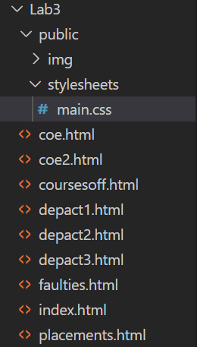

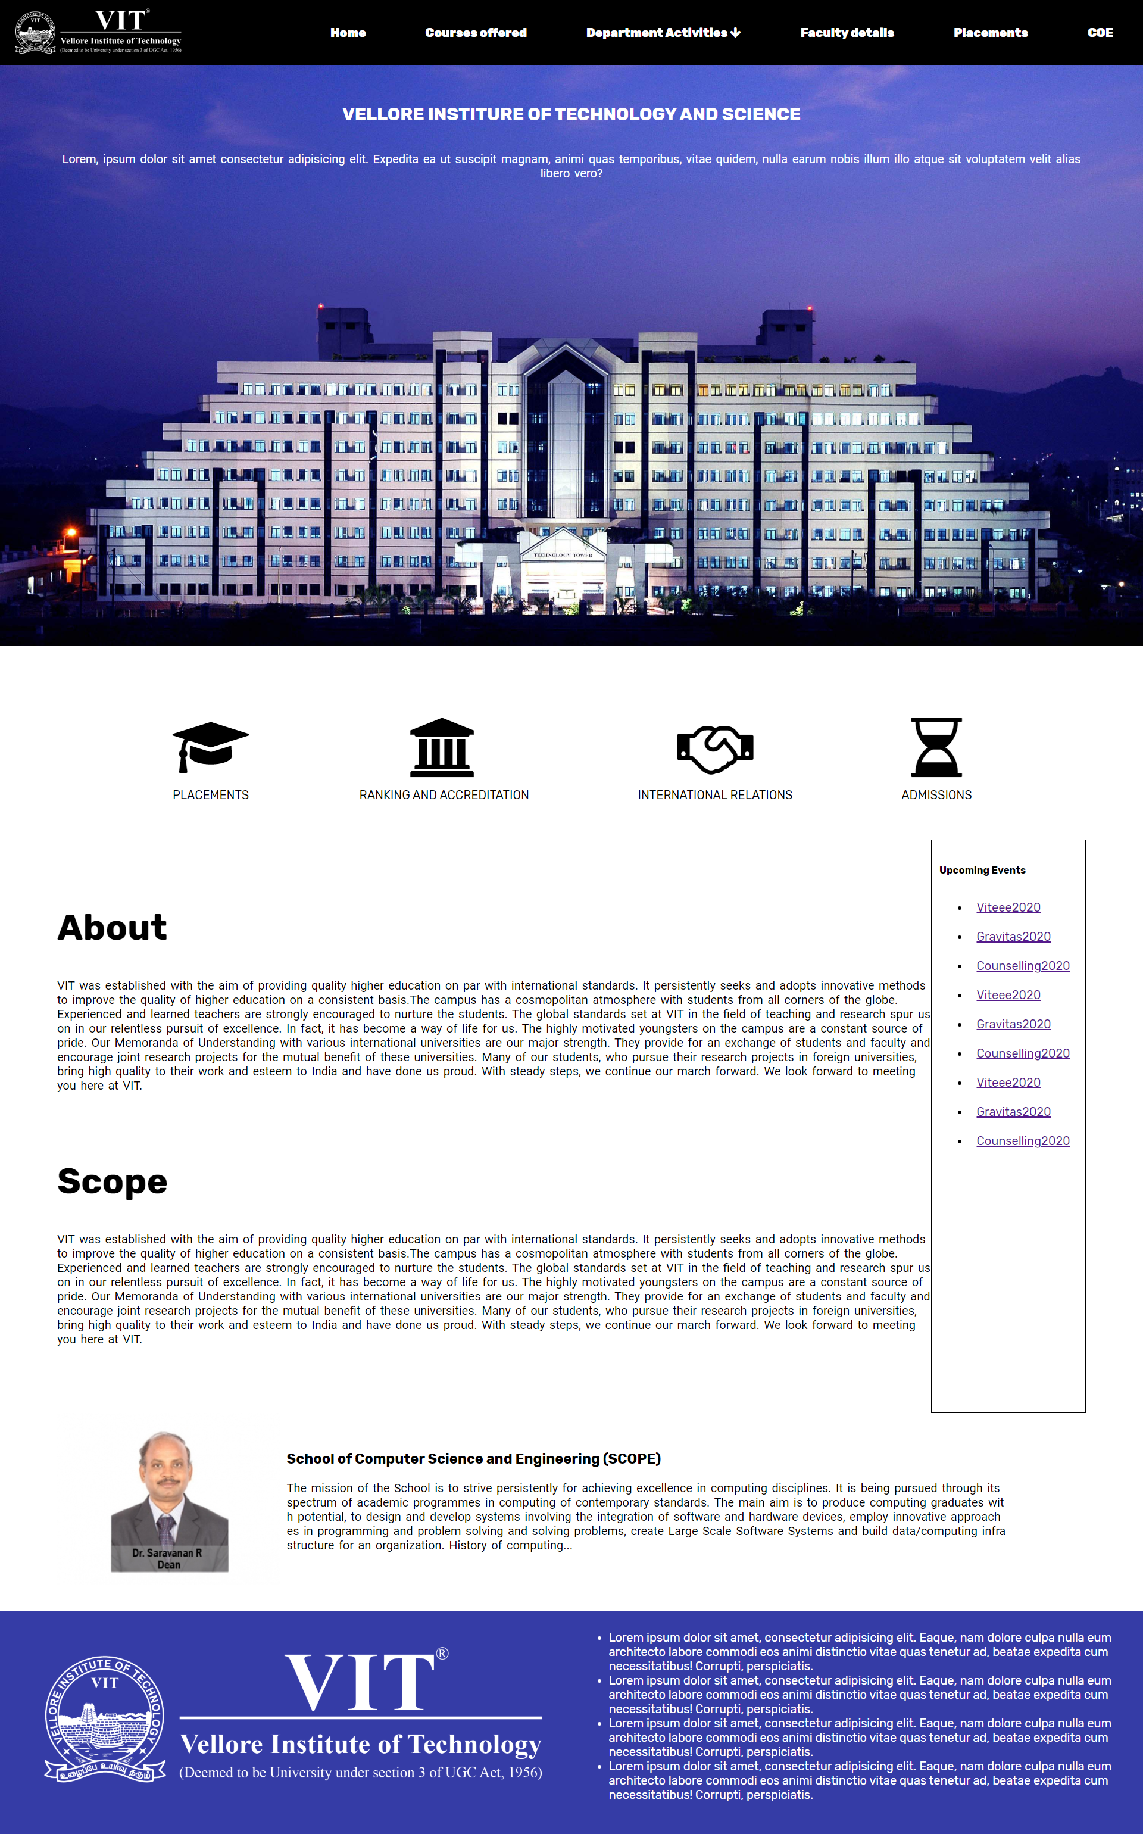

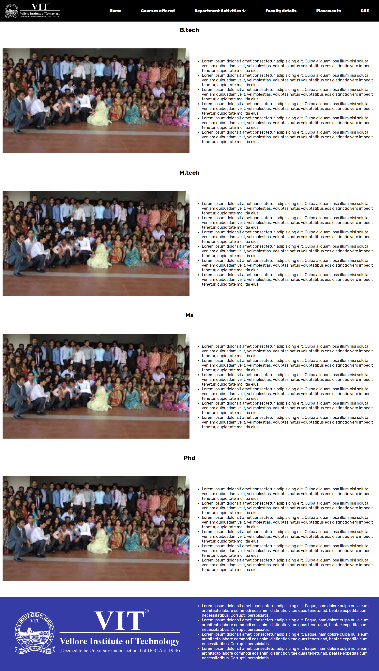

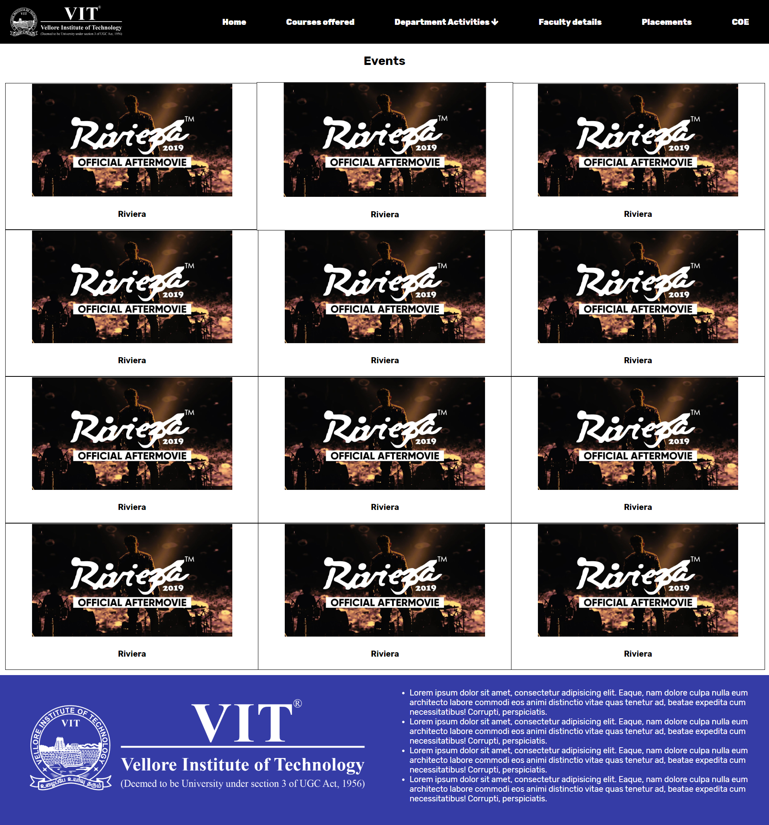

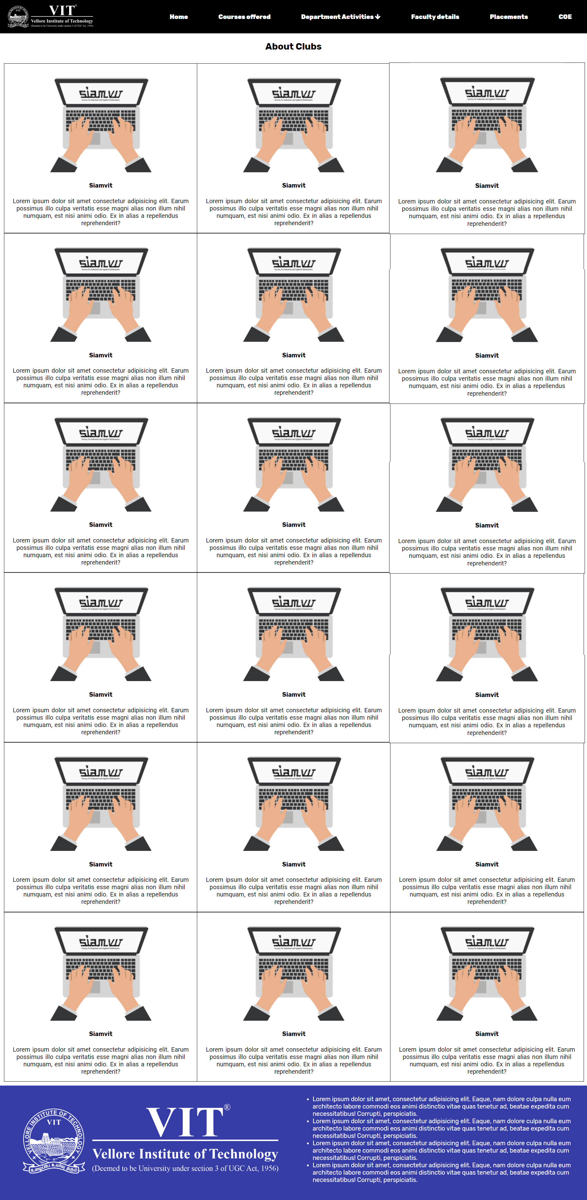

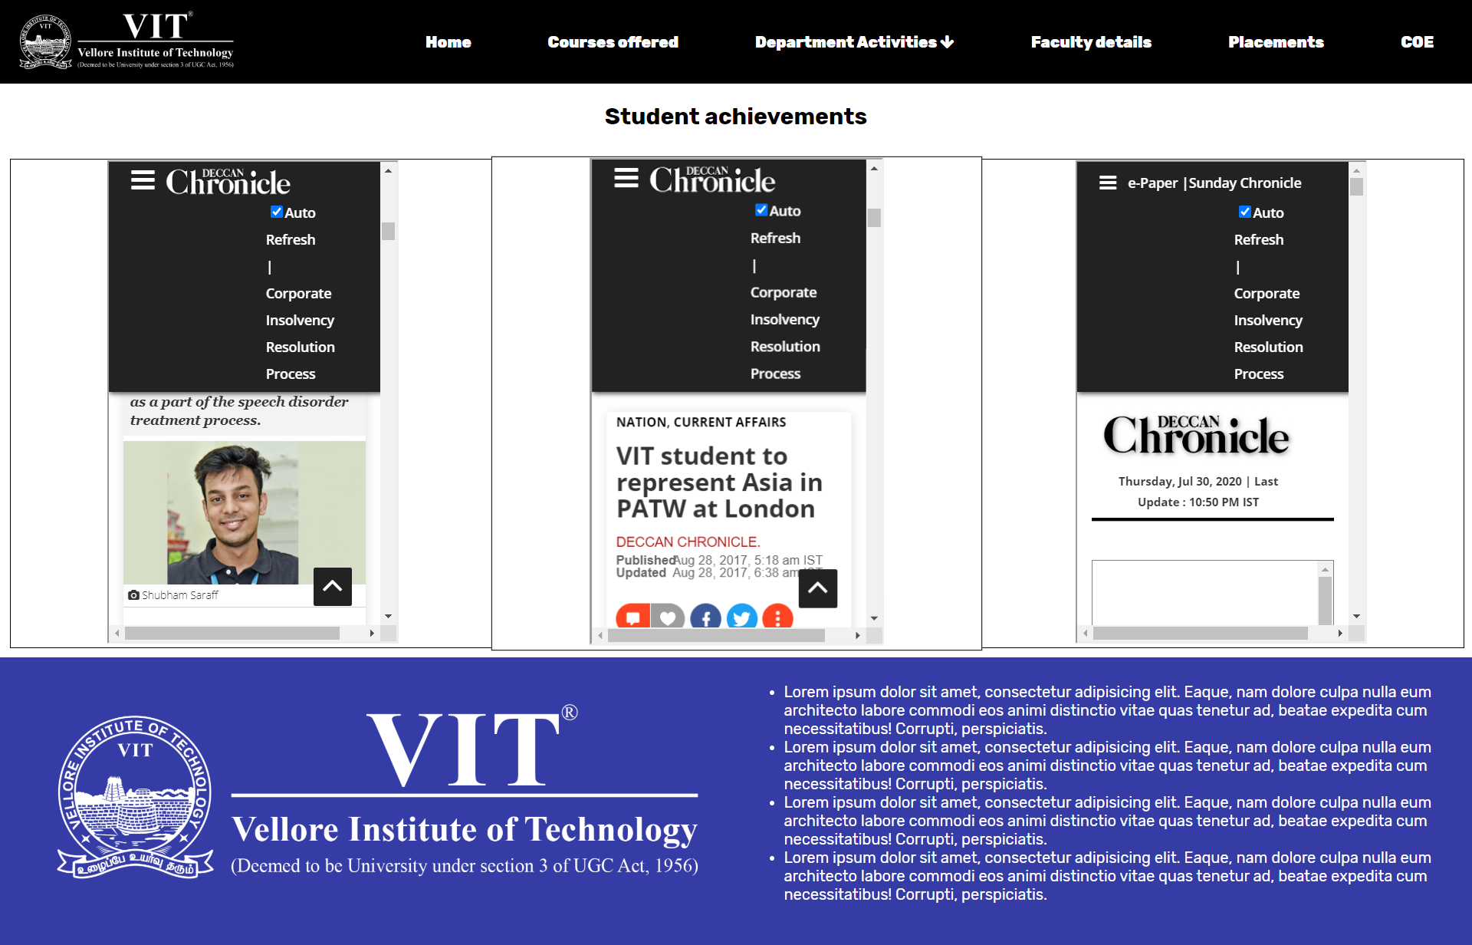

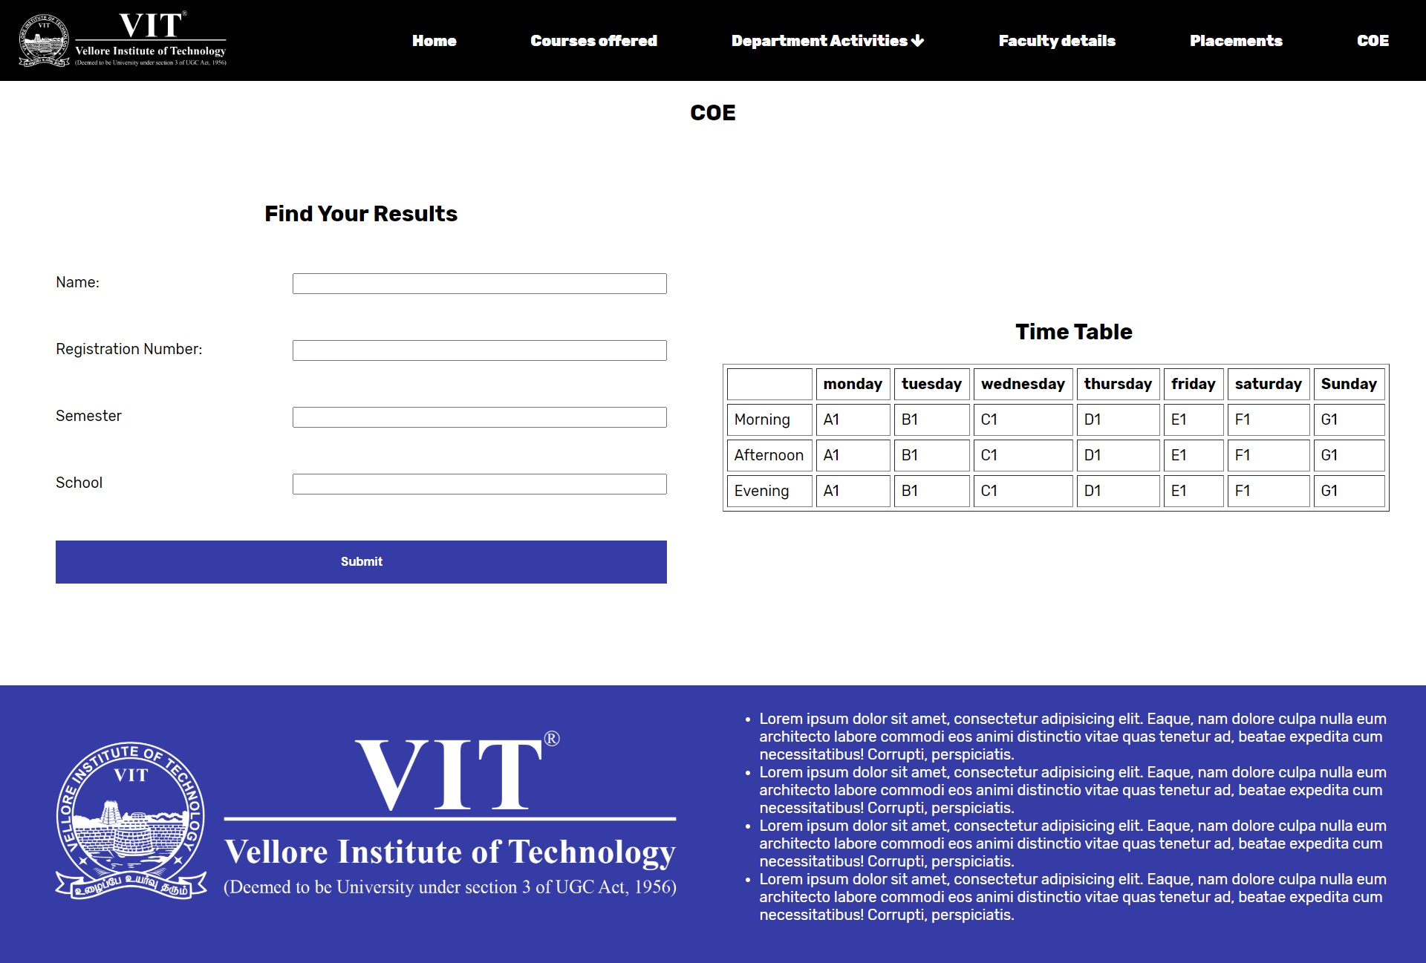

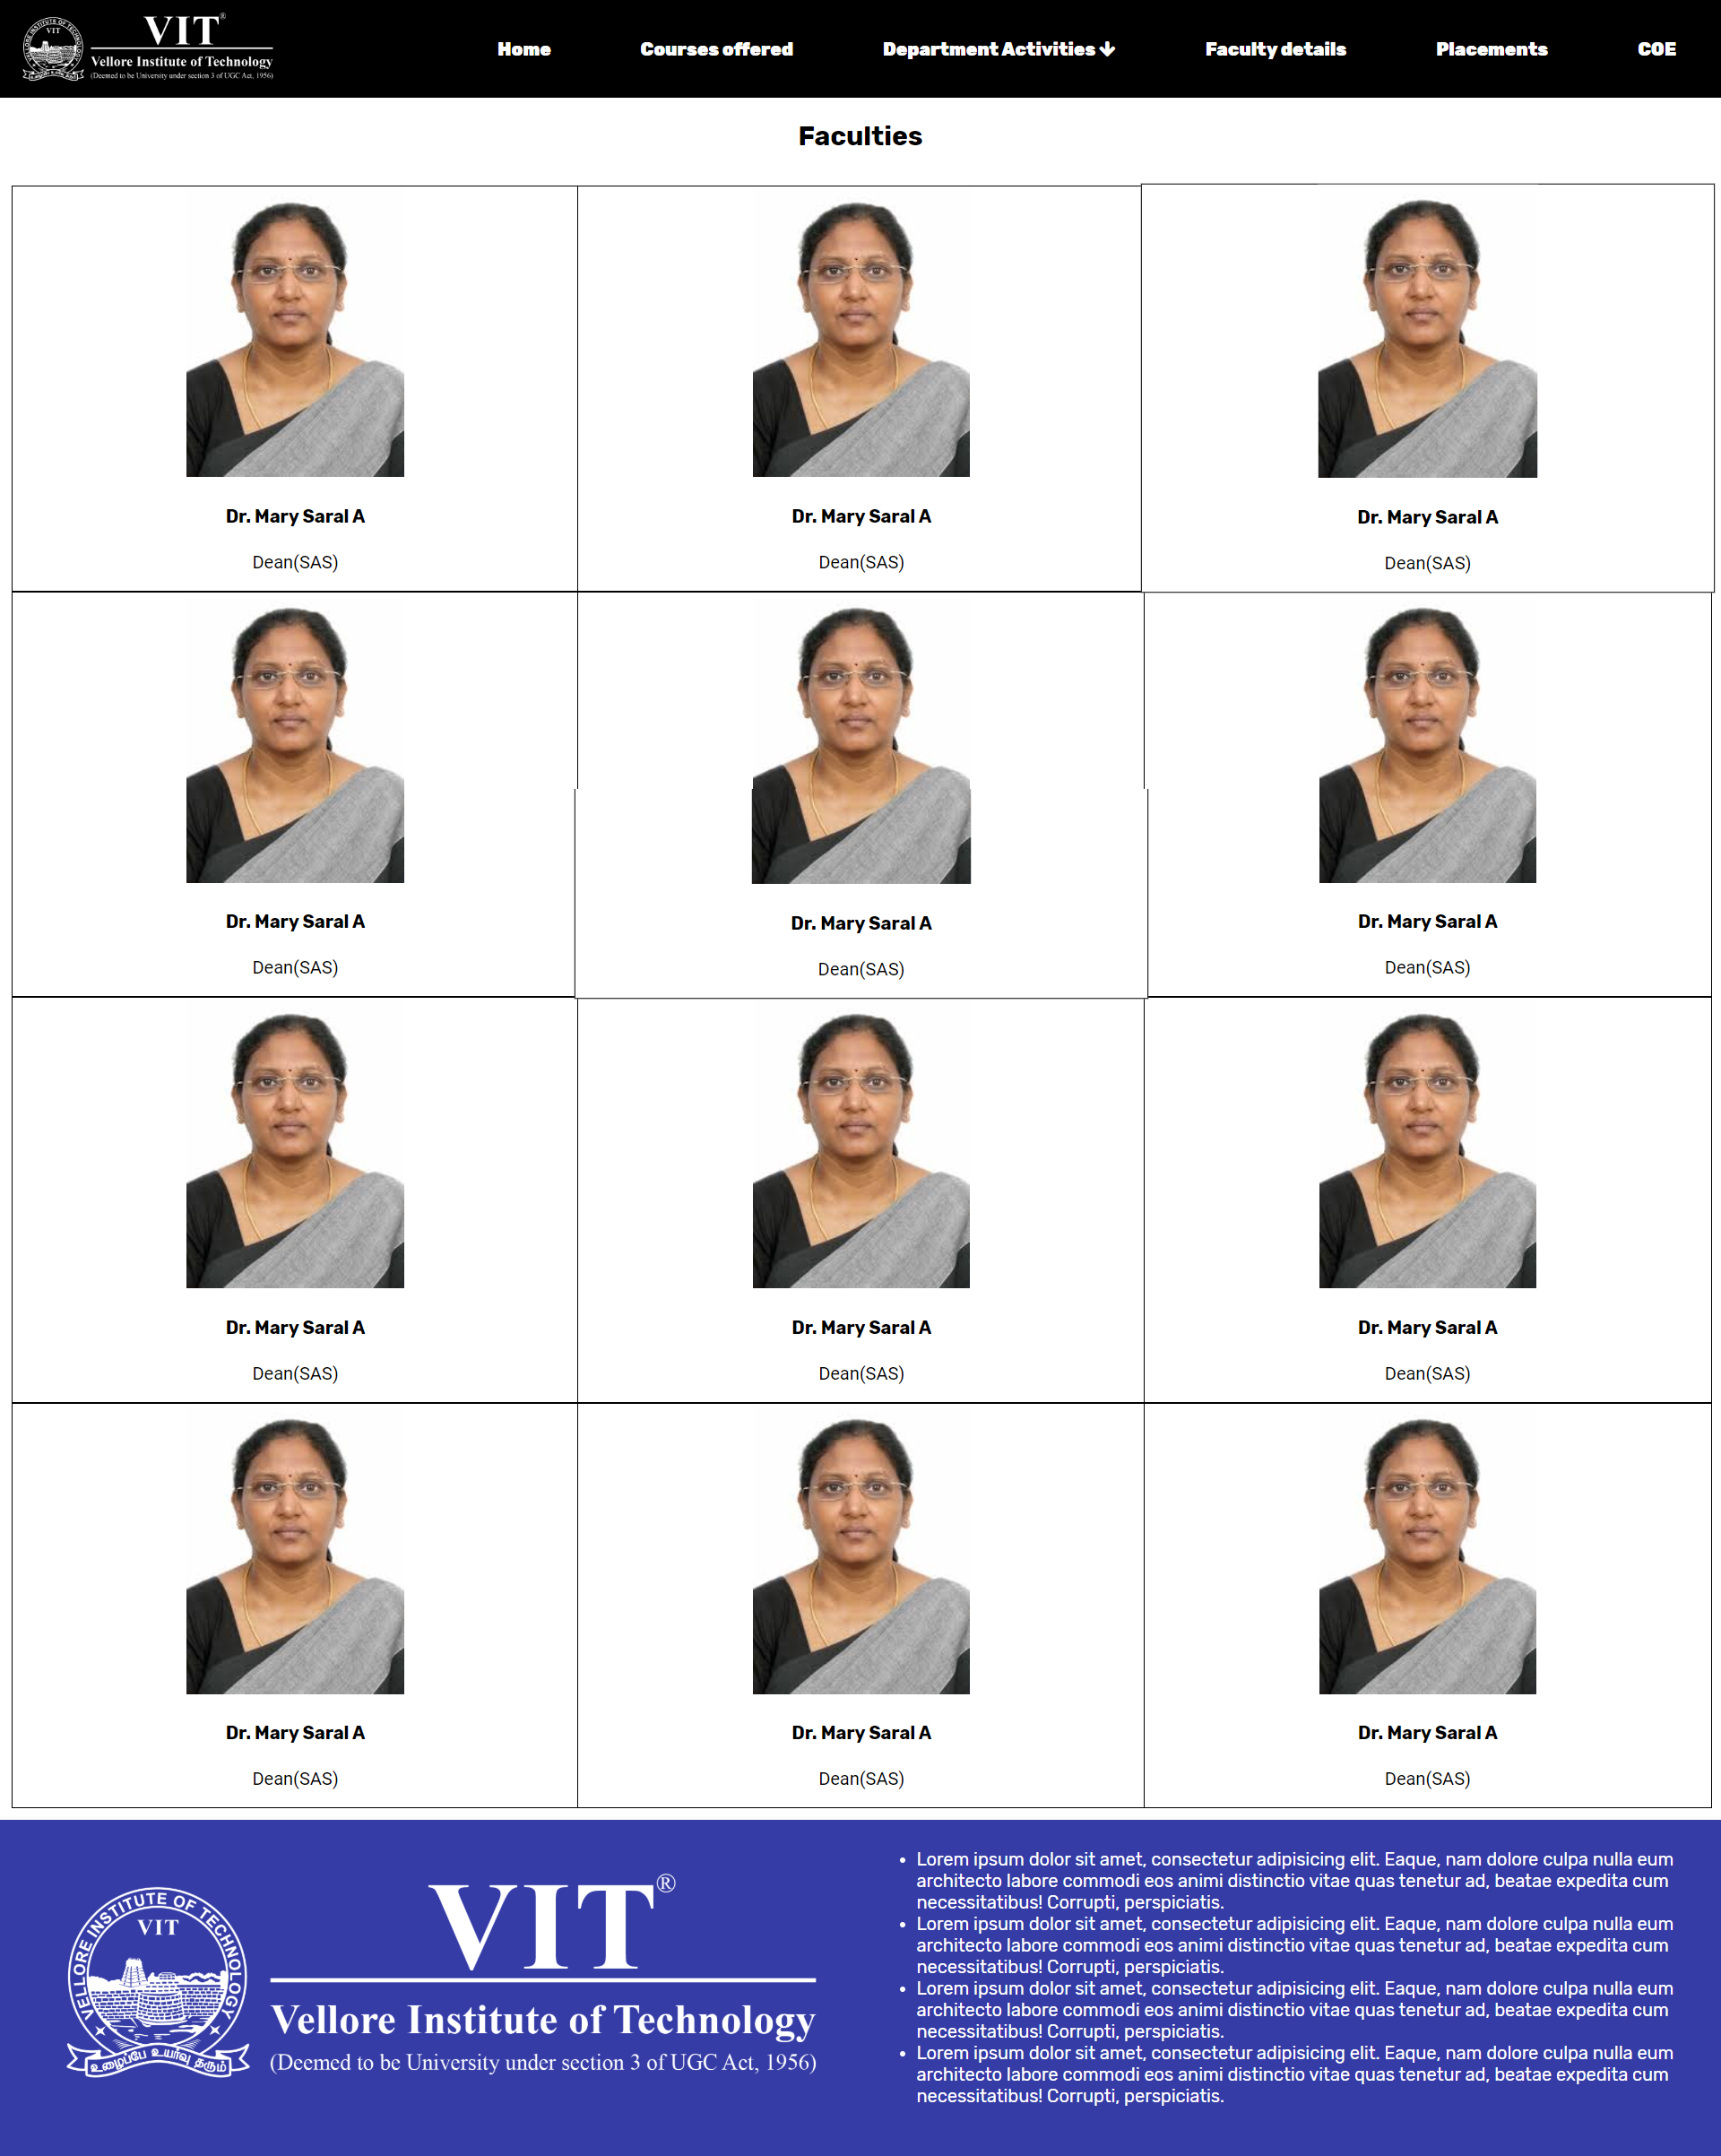

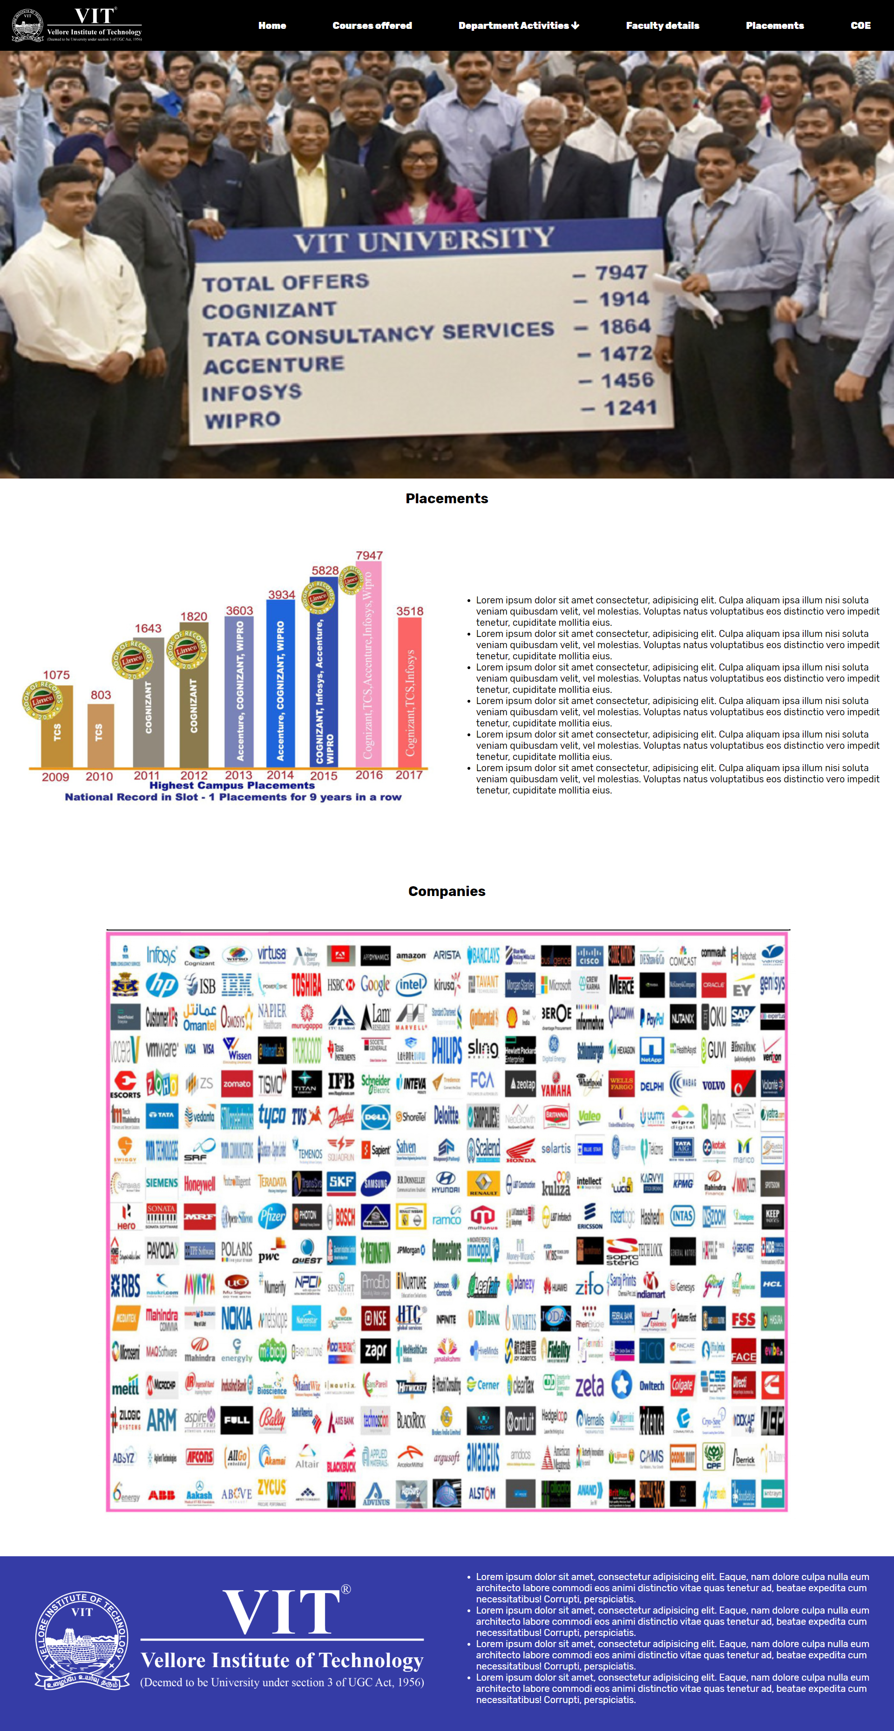

**Hosted at:**

[**https://sreemanthg.github.io/IWP-ASSIGNMENT-18BCE0745/**](https://sreemanthg.github.io/IWP-ASSIGNMENT-18BCE0745/)

**Full Code at:**

[**https://github.com/SreemanthG/IWP-ASSIGNMENT-18BCE0745**](https://github.com/SreemanthG/IWP-ASSIGNMENT-18BCE0745)

**This website is responsive, I.e It works in various types of devices**

**Thank you**